PI5USB30216C
USB Type-C Plug Orientation (CC Pins) Detector
Table of Contents
1 Introduction 2
2 Settings of PI5USB30216C 2
2.1 Port Role Setting via Pin Control Mode 2
2.2 Port Role Setting via I2C Control Mode 3
3 Processor Communication via I2C Control Mode 3
3.1 I2C Configuration Sequence 5
3.2 Power-up Sequence in I2C Control Mode with ENB tied to ground 6
3.3 Power-down and Power-up through ENB pin 6
3.4 Power-down and Power-up via Powersaving bit in I2C Control Mode 6
3.5 I2C Register Quick Reference Table 7
4 Typical Application Circuit 9
5 Layout Recommendation 9
5.1 Layout Recommendation 9
5.2 Layout Example 10
6. Software Example 11

Introduction
Pericom's PI5USB30216C is a Type-C Configuration Channel (CC) logic IC. The device implements CC pins for port attachment, detachment, cable orientation, role detection, and Type-C Current Mode control. The device supports host only mode (Source/DFP), device only mode (Sink/UFP) and dual role port (DRP/Try.SNK DRP and Try.SRC DRP) modes with automatic configuration based on the voltage levels detected on CC pins. The device supports both pin and I2C control mode. I2C control mode allows higher flexibility of port control and communications.

Packaging: 12-contact X2QFN (1.6mmx1.6mm)

Settings of PI5USB30216C
The Type-C port role of PI5USB30216C can be controlled via two modes – pin control and I2C control. ADDR pin is used to select the desired mode. If ADDR pin is set to either high or low, I2C control is active. SDA/OUT1 and SCL/OUT2 are used for I2C transaction. ADDR is also to set the I2C address. If ADDR pin is floating, pin control mode is active.

ADDR pin | I2C address format | I2C address
ADDR=GND | 7-bit addressing | 0x1D
 | 8-bit address | Write:0x3A; Read:0x3B
ADDR=VDD | 7-bit addressing | 0x3D
 | 8-bit address | Write:0x7A; Read:0x7B
ADDR=FLOAT | Pin control mode
Table 1: ADDR setting

2.1 Port Role Setting via Pin Control Mode
Default current host/DFP only mode, device/UFP only mode and default current Try.SNK DRP mode are available. PORT pin is used to configure the role of Type-C Port in pin control mode and the settings can be referred to the table below.

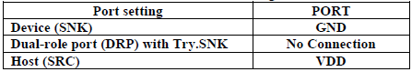
Table 2: Port Setting

2.2 Port Role Setting via I2C Control Mode
The settings of port role are referred to byte2 of I2C Register Description on Pericom datasheet.
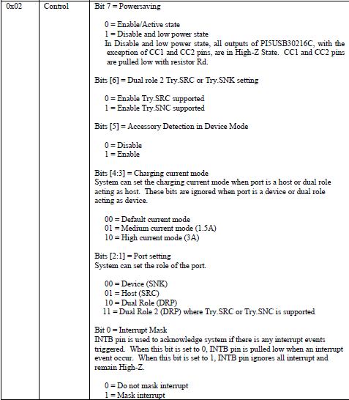
Table 3: Port Setting Register

3 Processor Communication via I2C Control Mode
Please noted that PI5USB30216C does not have offset byte*. All registers must be read or written sequentially from 0x01. For example, in order to read address 0x04, PI5USB30216C I2C registers must be read sequentially from 0x01, 0x02, 0x03 to 0x04. In order to write address 0x02, it must be written sequentially from 0x01 to 0x02.

*Please use “I2C Transport” API instead of “I2C SMBus” API to communicate with PI5USB30216C if needed.

Processor should use following procedure to process PI5USB30216C interrupt request:
- INTB asserted LOW, indicating Type-C port status change.
- Processor first masks PI5USB30216C interrupt by writing a ‘1’ to Bit 0 of Control Register(0x02). INTB returned Hi-Z.
- Processor then read Register(0x01), Control Register (0x02), Interrupt Register(0x03) and CC Status Register(0x04). Interrupt Register(0x03) indicates if an attach or detach event was detected. All interrupt flags in Interrupt Register will be cleared after the I2C read action. CC Status Register(0x04) is used to determine plugin details and charging profile. Processor can configure the power and USB channels according to information in CC Status Register.
- Processor unmask PI5USB30216C interrupt by writing a ‘0’ to Bit 0 of Address 0x02 before ending the interrupt service routine.

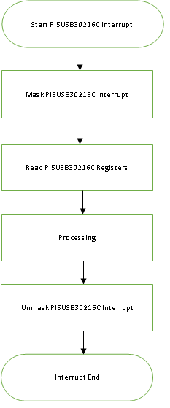

Figure 1: Suggested Flow of Processor Communication with PI5USB30216C via I2C Control Mode

3.1 I2C Configuration Sequence
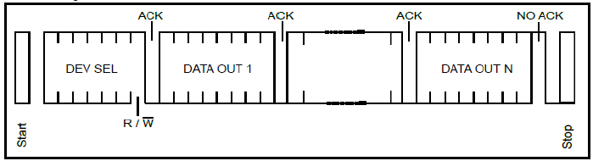
Figure 2: READ Sequence Diagram

Figure 4 below is one example for read sequence at ADDR=GND and Data Reg [1:4]=20,04,01,06.

Figure 3: I²C Read Sequence Sample

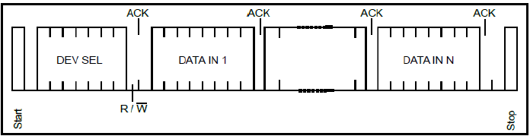
Figure 4: WRITE Sequence Diagram

Figure 6 below is one example for write sequence at ADDR=GND and Data Reg [1:2]=20,05.
Figure 5: I²C WRITE Sequence Sample

3.2 Power-up Sequence in I2C Control Mode with ENB tied to ground
The power-up sequence for the PI5USB30216C with ENB tied to ground is as follow:

1. When system is powered off and PI5USB30216C has no VDD, CC1 and CC2 are pulled low by PI5USB30216C and the port acts as a UFP/Sink.
2. System powered on and supply VDD to PI5USB30216C. PI5USB30216C is reset by POR.
3. PI5USB30216C in I2C control mode is always initialized as UFP only mode (Reg[0x02]=00h) regardless of PORT pin setting.
4. Write Reg[0x02]=81h
5. System can change PI5USB30216C to desired mode by writing byte2 according to “Port Setting Register” in section 2.2.
E.g. Write Reg[0x02]=46h to set the port to Try.SNK DRP default current mode.
6. PI5USB30216C monitors CC pins and VBUS for attachment and detachment.

3.3 Power-down and Power-up through ENB pin

The power-down sequence for the PI5USB30216C using ENB is as follow:
1. Pull high ENB to disable PI5USB30216C. PI5USB30216C will pull-low INTB.
2. PI5USB30216C I2C is still accessible and the system should read PI5USB30216C I2C as usual to clean the interrupt.
3. The device is in disabled state and will pull low CC1 and CC2 and the port acts as a UFP/Sink.
4. User can re-enable the part by pull low ENB pin.

3.4 Power-down and Power-up via Powersaving bit in I2C Control Mode

When ENB is low, user can put PI5USB30216C into low power state via I2C as follow:
- Write Reg[0x02]=81h to put the part in powersaving mode.
- Read PI5USB30216C I2C to clear byte3 and byte4.
- The device will also pull low CC1 and CC2 and the port acts as a UFP/Sink.
4 User can re-enable the part by writing desired mode to byte2 according to “Port Setting Register” in section 2.2.
E.g. Write Reg[0x02]=46h to set the port to Try.SNK DRP default current mode.

3.5 I2C Register Quick Reference Table

Reg[0x02] | PI5USB30216C Operating Mode | CC1/2 voltage when unattached | ID pin
00h | Sink/UFP; No accessory support | GND | “H”
01h | Sink/UFP; No accessory support; Mask Interrupt
02h | Source/DFP; Default USB Power | VDD | “L” when  UFP is  attached
03h | Source/DFP; Default USB Power; Mask Interrupt
04h | DRP; Default USB Power | Toggle between VDD and GND
05h | DRP; Default USB Power; Mask Interrupt
06h | Try.SRC DRP; Default USB Power | Toggle between VDD and GND
07h | Try.SRC DRP; Default USB Power; Mask Interrupt
0Ah | Source/DFP; 1.5A Type-C Current Mode | VDD
0Bh | Source/DFP; 1.5A Type-C Current Mode; Mask Interrupt
0Ch | DRP; 1.5A Type-C Current Mode | Toggle between VDD and GND
0Dh | DRP; 1.5A Type-C Current Mode; Mask Interrupt
0Eh | Try.SRC DRP; 1.5A Type-C Current Mode | Toggle between VDD and GND
0Fh | Try.SRC DRP; 1.5A Type-C Current Mode; Mask Interrupt
12h | Source/DFP; 3A Type-C Current Mode | VDD
13h | Source/DFP; 3A Type-C Current Mode; Mask Interrupt
14h | DRP; 3A Type-C Current Mode | Toggle between VDD and GND
15h | DRP; 3A Type-C Current Mode; Mask Interrupt
16h | Try.SRC DRP; 3A Type-C Current Mode | Toggle between VDD and GND
17h | Try.SRC DRP; 3A Type-C Current Mode; Mask Interrupt
46h | Try.SNK DRP; Default USB Power | Toggle between VDD and GND
47h | Try.SNK DRP; Default USB Power; Mask Interrupt
4Eh | Try.SNK DRP; 1.5A Type-C Current Mode | Toggle between VDD and GND
4Fh | Try.SNK DRP; 1.5A Type-C Current Mode; Mask Interrupt
56h | Try.SNK DRP; 3A Type-C Current Mode | Toggle between VDD and GND
57h | Try.SNK DRP; 3A Type-C Current Mode; Mask Interrupt
20h | Sink/UFP; Support accessory | Toggle between VDD and GND | “H”
21h | Sink/UFP; Support accessory; Mask Interrupt
Table 4: Control Register (Reg[0x02]) Quick Reference Table

Reg[0x03] | PI5USB30216C Attach/Detach Event
00h | No attach or detect event occurred since last I²C read.
01h | Attach event occurred since last I²C read.
02h | Detach event occurred since last I²C read.
Table 5: Interrupt Register (Reg[0x03]) Quick Reference Table

Reg[0x04] | Type-C Port Status | Plug Position | CC1 Voltage | CC2 Voltage | ID
00h | Unattached; The port shall not drive VBUS. | - | - | - | H
05h/15h | Attached to a Sink/UFP;  The port shall drive VBUS. | CC1 | Default Host: 0.4V | - | L
1.5A Host:
0.9V
3A Host:
1.7V
06h/16h | Attached to a Sink/UFP;  The port shall drive VBUS. | CC2 | - | Default Host: 0.4V | L
1.5A Host:
0.9V
3A Host:
1.7V
0Fh | Attached to an audio accessory. ^{*4} | Accessory | 0.1V | 0.1V | H
13h | Attached to a debug accessory. ^{*4} | Accessory | 0.4V | 0.4V | H
8Fh | Attached to a charge-through audio accessory | Accessory | 0.1V | 0.1V | H
93h | Attached to a debug accessory and VBUS is detected. ^{*4} | Accessory | 0.4V | 0.4V | H
A9h | Attached to a Host; ^{*1} | CC1 | 0.9V | - | H
AAh | Attached to a Host; ^{*1} | CC2 | - | 0.9V | H
C9h | Attached to a Host; ^{*2} | CC1 | 0.9V | - | H
CAh | Attached to a Host; ^{*2} | CC2 | - | 0.9V | H
E9h | Attached to a Host; ^{*3} | CC1 | 1.7V | - | H
EAh | Attached to a Host; ^{*3} | CC2 | - | 1.7V | H
Table 6: Status Register (Reg[0x04]) Quick Reference Table

Note
*1: The port shall draw no more than the default USB power from VBUS.
*2: The port shall draw no more than 1.5A from VBUS.
*3: The port shall draw no more than 3A from VBUS.
*4: According to Type-C spec 1.1, the port shall not drive VBUS.

4 Typical Application Circuit

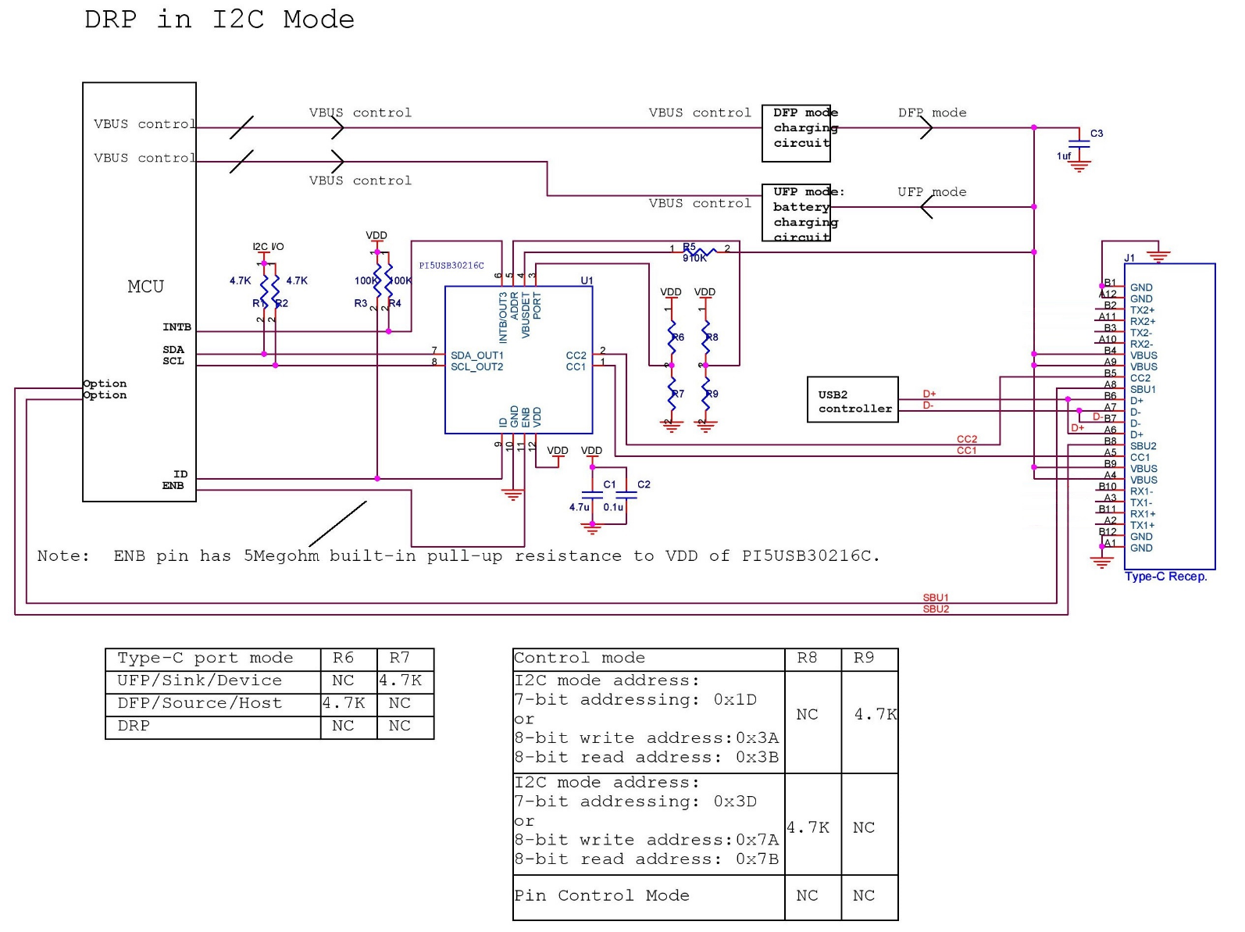
Figure 6: Typical Application Circuit of PI5USB30216C

5 Layout Recommendation

5.1 Layout Recommendation
At least 1pc 4.7uF and 1pc 0.1uF decoupling capacitors are recommended for VDD of PI5USB30216C. Each decoupling capacitor should be connected to PCB power plane via shortest path. VDD and GND pins should be
shorted to PCB power planes via shortest paths.

At least 1uF decoupling capacitor is recommended at VBUS.

5.2 Layout Example

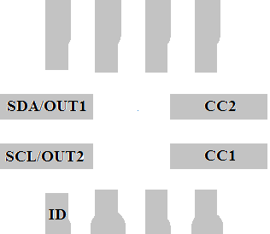
Figure 7: PI5USB30216C Layout

6. Software Example

char i2c_read_buf[4]={0x00,0x00,0x00,0x00};
char i2c_write_buf[2]={0x00,0x00};

void PI5USB30216C_INTN_handler (void)
{
char int_status = 0x00; //Interrupt status;
char cc_status =0x00;
char port_status=0x00;
char control_status;

i2c_write_buf[1]=0x47; //Mask PI5USB30216C interrupt. E.g. in Try.SNK DRP mode, write Reg[0x02]=47h
PI5USB30216C_i2c_write(PI5USB30216C_slaveAddr,i2c_write_buf,2);

PI5USB30216C_i2c_read(PI5USB30216C_slaveAddr, i2c_read_buf, 4);
//Read PI5USB30216C registers when Interrupt occurred

control_status=i2c_read_buf[1];

int_status = i2c_read_buf[2];
if(int_status&0x02)
{
printf("Unpluged.\n");
switch_off_VBUS_PWR(); //CPU switch off the VBUS power supply when port unpluged
//Per TypeC spec, Source removes VBUS and reaches vsafe0V within 650ms.
}
if(int_status&0x01) printf("Plug in.\n");

cc_status = i2c_read_buf[3];
if(cc_status&0x01) printf("CC1 connected.\n");

if(cc_status&0x02) printf("CC2 connected.\n");

port_status = (i2c_read_buf[3]>>2)&0x07;
if((cc_status&0x01)|(cc_status&0x02))
{
switch(port_status)
{
case 1:
printf("Device plug in.\n");
switch_on_VBUS_PWR(); //CPU switch on the VBUS power supply when UFP/Device plug in.
break;
case 2:
printf("Host plug in.\n");
break;
case 3:
printf("Audio Adapter Accessory plug in.\n");
break;
case 4:
printf("Debug Accessory plug in.\n");
break;
case 5:
printf(Device plug in with active cable.\n”);
switch_on_VBUS_PWR(); //CPU switch on the VBUS power supply when UFP/Device plug in.
break;
default:
break;
}
}

i2c_write_buf[1]=0x46; //Unmask PI5USB30216C interrupt. E.g. in Try.SNK DRP mode, write Reg[0x02]=46h
PI5USB30216C_i2c_write(PI5USB30216C_slaveAddr,i2c_write_buf,2);
}

void Initial_prog(void)
{

i2c_write_buf[1]=0x81; //Reset
PI5USB30216C_i2c_write(PI5USB30216C_slaveAddr,i2c_write_buf,2);
delay(10);
i2c_write_buf[1]=0x46; //Support Try.SNK DRP mode
PI5USB30216C_i2c_write(PI5USB30216C_slaveAddr,i2c_write_buf,2);
set_ENB_low(); //Enable the PI5USB30216C when ENB pin by GPIO control

}

Void Power_off(void)
{

//If power-down via powersaving bit
i2c_write_buf[1]=0x81; //Enter Power_saving mode when CPU power off
PI5USB30216C_i2c_write(PI5USB30216C_slaveAddr,i2c_write_buf,2);
delay(10);
///

//If power-down via ENB pin
set_ENB_High(); //Disable PI5USB30216C via ENB pin
delay(10);
//

//System should read byte3 and byte4 to clear them regardless of power-down method
PI5USB30216C_i2c_read(PI5USB30216C_slaveAddr, i2c_read_buf, 4);

}

