PI5A3157 IBIS Model Check
Two IBIS Models: PI5A3157_C_RevA.ibs and PI5A3157_ZA_RevA.ibs.
1. Model Type
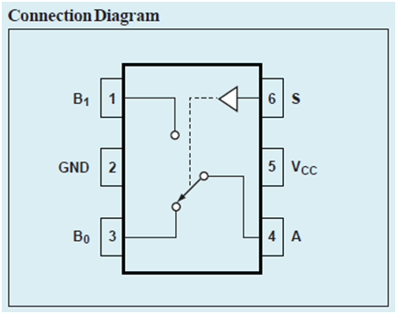[Pin] signal_name model_name
1 B1 TERM1
2 GND POWER
3 B0 TERM1
4 A TERM2
5 VCC POWER
6 S INPUT

[Series Pin Mapping]
4 1 SWITCH1 1
4 3 SWITCH1 1

Conclusion
1. The PIN and PIN mapping information described in IBIS model is exactly correct according to the datasheet.

2. Switch ON Resistance based on IBIS Model:
Simulation by HSPICE tool with following two conditions: Vcc=3.3v(Defined in IBIS model)
1) Io=24mA, Vin=0V: We get Vout=0.14885V, so Ron=6.2021Ω
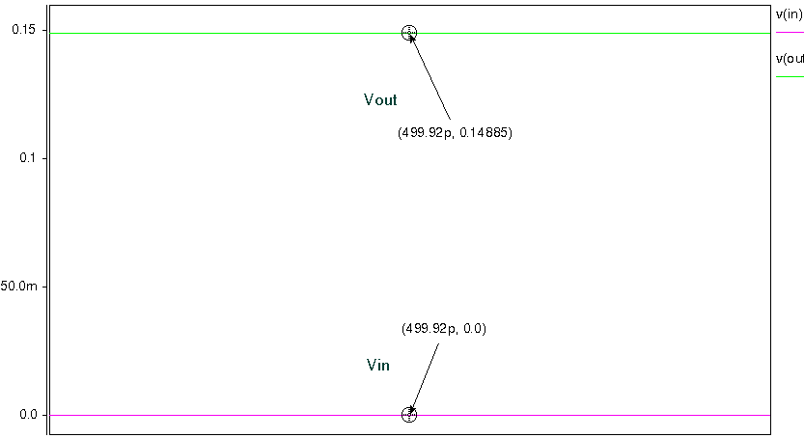
2) Io=-24mA, Vin=3V: We get Vout=2.6847V, so Ron=13.1375Ω
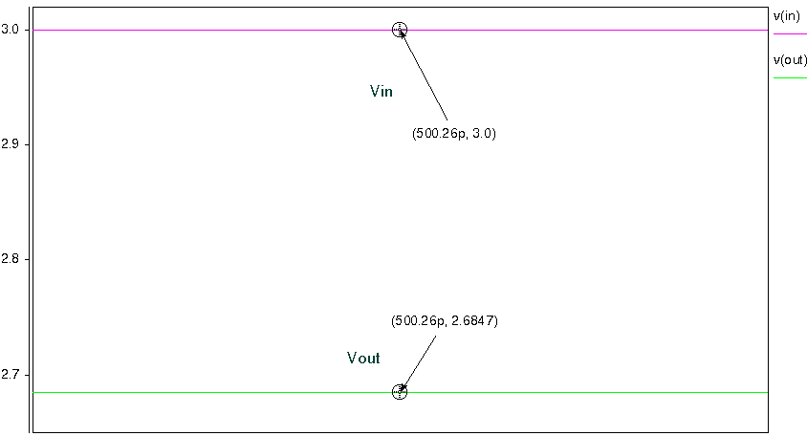
Conclusion:
The values of Switch ON Resistance based on Hspice simulation with IBIS model are correct according to the datasheet.
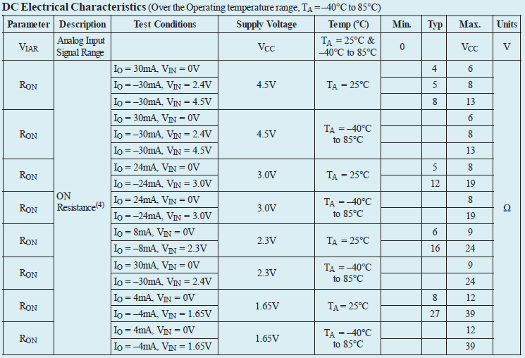

3. Analog Switch simulation result with following circuit diagram:
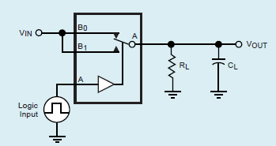
Input signal frequency is 250MHz, with 10pF pull-down capacitance and 100Ω pull-down resistor to the Output.
