PI3WVR12612NEE
Demo Board Rev.B User Manual
by Ada Yip

Table of Contents

1 Introduction 2
2 Overview 2
3 Quick Start 4
4 Circuit Description 5
4.1 Port Selection 5
4.2 3.3V/5V Power Supply 5
4.3 Power Saving Mode 6
4.4 DP Main-link Path in DP Section 6
4.5 AUX/DDC Path in DP Section 7
5 References 7
6 Appendix A: Demo Board Schematic 8

Introduction

PI3WVR12612 is a 4-lane mux or de-mux DP1.2 and HDMI1.4 switch for source as well as sink applications. This user manual describes the components and the usage of PI3WVR12612NEE demo board rev.B for source application.

Overview

Figure 1 and 2 are the block diagrams DP section and HDMI section, respectively, of Pericom PI3WVR12612NEE demo board rev.B. Top view and layout of the demo board are shown in figures 3 and 4, respectively. For source application evaluation, two DP plug connector (J101) on PI3WVR12612NEE demo board is used for plugging a DP source device, such as graphic card. A DP cable can be connected between a DP receptacle connector (J102 or 103) on the demo board and a DP sink device, such as DP monitor. +5V DC can be employed to the demo board via a mini USB female connector (J104). Through a 3.3V regulator (U103), PI3WVR12612 on the demo board can then be powered up. Port selection and AUX/DDC selection of PI3WVR12612 can be selected via a SPDT switch (SW101).

DP Output Connectors
Mini USB Connector
PI3WVR12612
J103
3.3V Regulator
Port A
U103
SW101
SPDT Switch
J101
DP Input Connector
Input Port
U101
J104
+5V
+3V3_USB
Port B
J102
Port A
PI5C3257
U102
Port B
Input Port
CEC
CAB_DET
CEC_A
CAB_DET_A

CEC_B
CAB_DET_B
ML
ML_A
ML_B
+3V3_DP

Figure 1: Block Diagram of DP Section on PI3WVR12612NEE Demo Board Rev.B
HDMI Input Connector
Mini USB Connector
PI3WVR12612
J107
3.3V Regulator
Port A
U103
SW102
SPDT Switch
J105
HDMI Output Connectors
Input Port
U104
J104
+5V
+3V3_USB
Port B
J106
Port A
PI5C3257
U102
Port B
Input Port
CEC
CEC_A

CEC_B
TMDS
TMDS_A
TMDS_B

Figure 2: Block Diagram of HDMI Section on PI3WVR12612NEE Demo Board Rev.B
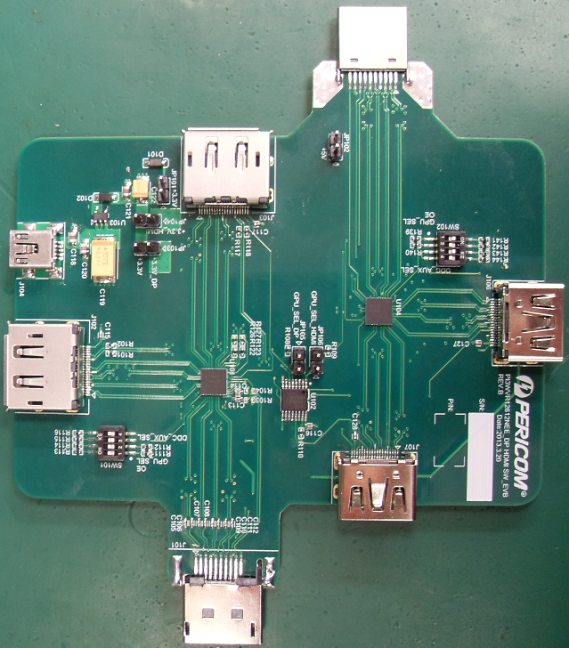

Figure 3: Top View of PI3WVR12612NEE Demo Board Rev.B
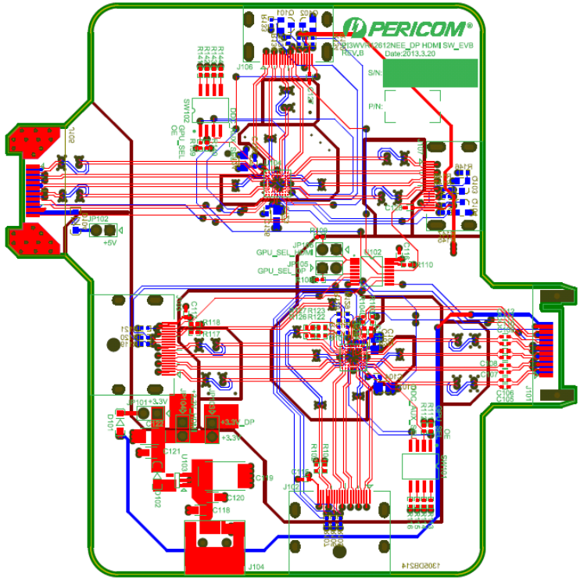

Figure 4: Layout of PI3WVR12612 Demo Board Rev.B

Quick Start

To start-up the DP section of PI3WVR12612NEE demo board rev.B, complete the following steps:
- Close pins 1 and 8 of SPDT switch SW101 open to set OE pin to high;
- Leave pins 2 and 7 of SPDT switch SW101 open to select Port A of PI3WVR21612 at U101;
- Leave pins 3 and 6 of SPDT switch SW101 open while closing pins 4 and 5 to set DDC_AUX_SEL low, which is to enable AUX path and disable DDC path;
- Add jumper to header JP105 for DP evaluation;
- Add jumper to header JP103 to feed the 3.3V power to VDD of PI3WVR12612 at U101;
- Add jumper to header JP101 if using the 3.3V from DP source to power up PI3WVR12612 at U101;
- Supply 5V to demo board from mini USB connector at J104;
- Plug a source device, e.g. DP motherboard, to DP input connector J101 on demo board;
- Connect a sink device, e.g. DP monitor, to a DP output connector at J102 or 103.

To start-up the HDMI section of PI3WVR12612NEE demo board rev.B, complete the following steps:
- Close pins 1 and 8 of SPDT switch SW101 open to set OE pin to high;
- Leave pins 2 and 7 of SPDT switch SW101 open to select Port A of PI3WVR21612 at U104;
- Close pins 3 and 6 as well as pins 4 and 5 of SPDT switch SW101 to set DDC_AUX_SEL medium, which is to enable DDC path;
- Add jumper to header JP106 for HDMI evaluation;
- Add jumper to header JP104 to feed the 3.3V power to VDD of PI3WVR12612 at U104;
- Add jumper to header JP102 if feeding the 5V from HDMI source to 3.3V regulator for powering up PI3WVR12612 at U104;
- Supply 5V to demo board from mini USB connector at J104;
- Plug a source device, e.g. HDMI motherboard, to HDMI input connector J105 on demo board;
- Connect a sink device, e.g. HDMI monitor, to an HDMI output connector at J106 or 107.

Circuit Description

Port Selection

PI3WVR12612 offers two control pins for selecting ports for high-speed signals, HPD and AUX/DDC. Switches SW101 and SW102 are used to select the control pin settings for PI3WVR21612 at U101 for DP evaluation and U104 for HDMI evaluation, respectively.

GPU_SEL  (Pins 2 and 7 of SW101/2) | DDC_AUX_SEL  (Pins 3 and 6 of SW101/2) | DDC_AUX_SEL  (Pins 4 and 5 of SW101/2) | Function
Low (Open) | Low (Open) | Low (Short) | Port A HS, AUX and HPD active
Low (Open) | High (Short) | High (Open) | Port A HS, DDC through AUX path and HPD active
Low (Open) | Medium (Short) | Medium (Short) | Port A HS, AUX, DDC and HPD active
High (Short) | Low (Open) | Low (Short) | Port B HS, AUX and HPD active
High (Short) | High (Short) | High (Open) | Port B HS, DDC through AUX path and HPD active
High (Short) | Medium (Short) | Medium (Short) | Port B HS, AUX, DDC and HPD active

Table 1: Port Selection of PI3WVR12612 Demo Board Rev.B
For CAD_DET and CEC signal switching using PI5C3257, header JP105 should be shorted for DP port selection while header JP106 should be shorted for HDMI port selection.

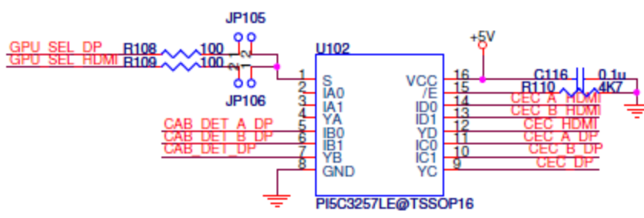

Figure 5: Port Selection for PI5C3257 on PI3WVR12612 Demo Board Rev.B

3.3V/5V Power Supply

Header JP103 is shorted for DP evaluation and header JP104 is shorted for HDMI evaluation. External 5V is supplied from the mini-USB connector at J104 to provide 5V power for sideband signals connected to and from PI5C3257 at U102.

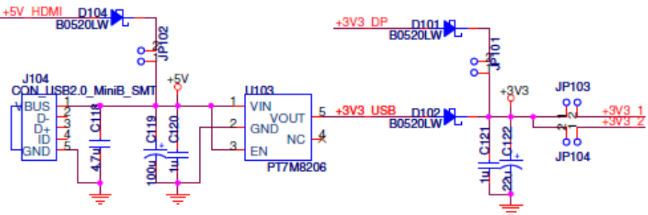

Figure 6: 3.3V/5V Power Paths for PI3WVR12612 Demo Board Rev.B
If 3.3V from a DP source is used for powering up the DP section of the demo board, header JP101 is shorted. If 5V from an HDMI source is used, header JP102 is shorted.

Figure 7: 3.3V/5V Source Powers for PI3WVR12612 Demo Board Rev.B

Power Saving Mode

PI3WVR12612 can enter power saving mode by setting OE pin to low voltage level.

OE | I/O Pins of PI3WVR12612 | Pins 1 and 8 of SW101 | Pins 1 and 8 of SW102
H | Normal Mode | Short for DP Evaluation | Short for HDMI Evaluation
L | Power Saving Mode | Open for DP Evaluation | Open for HDMI Evaluation

Table 2: OE Setting of PI3WVR12612 Demo Board Rev.B

DP Main-link Path in DP Section

0.1uF AC coupling capacitors at C105-112 are employed on all main-link channels beside the input DP connector at J101 assuming that input source is DC coupled. If input source is already AC coupled, these AC coupling capacitors can be replaced by 0Ω resistors. Similarly, 0.1uF AC coupling capacitors at C113-4 are originally designed for AUX channels and can be replaced by 0Ω resistors if input source is AC coupled.

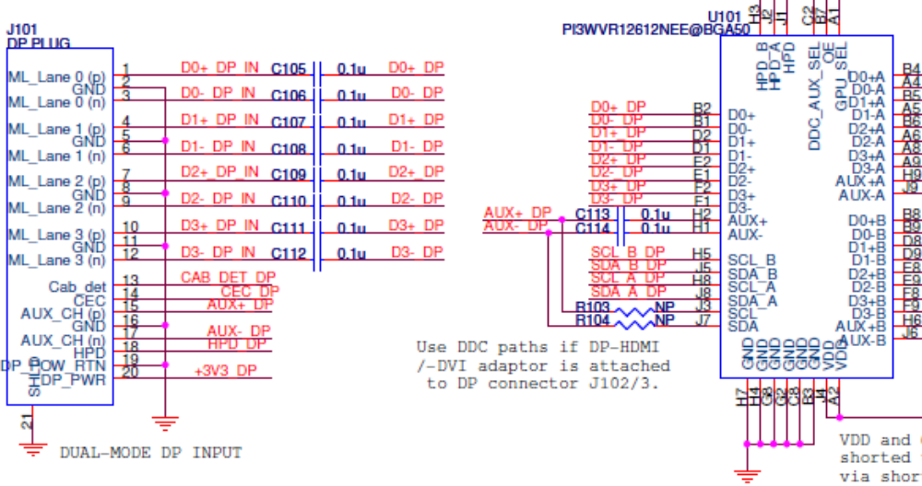

Figure 8: AC Coupling Capacitors on Main-link and AUX Paths of PI3WVR12612 Demo Board Rev.B

AUX/DDC Path in DP Section

At default demo board setting, input and output AUX paths of PI3WVR12612 at U101 are selected. If a dual-mode DP source device is attached to input DP connector at J101 and a TMDS sink device is attached to an output DP connector at J102/3, DDC signals are transmitted through AUX path of the input DP connector. Thus, AC coupling capacitors at C113-4 should be removed and 0Ω resistors should be assembled on R103-4 to use the input DDC paths of PI3WVR12612 at U101. Similarly, R122-5 resistors should be removed and 0Ω resistors should be assembled on R126-9 to connect output DDC paths of PI3WVR12612 at U101.

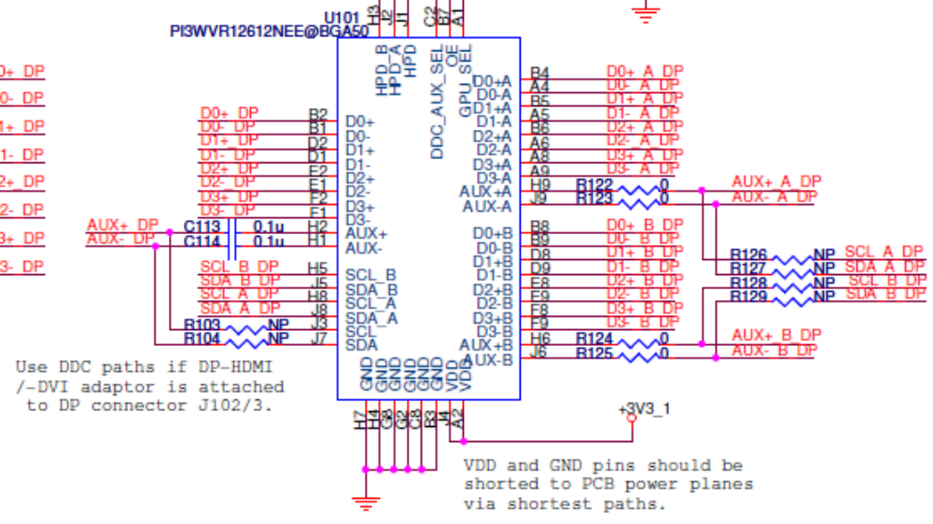

Figure 9: Main-link and AUX/DDC Connections of PI3WVR12612 Demo Board Rev.B

References

- VESA DisplayPort Standard Version 1 Revision 2, Video Electronics Standards Association, January 5, 2010
- VESA DisplayPort Dual-Mode Standard Version 1, Video Electronics Standards Association, February 10, 2012
- VESA DisplayPort Interoperability Guideline Version 1.1a, Video Electronics Standards Association, February 5, 2009
- High-Definition Multimedia Interface Specification Version 1.4, HDMI Licensing, LLC, June 5, 2009
- High-Definition Multimedia Interface Compliance Test Specification Version 1.4a, HDMI Licensing, LLC, 2010/03/04

Appendix A: Demo Board Schematic

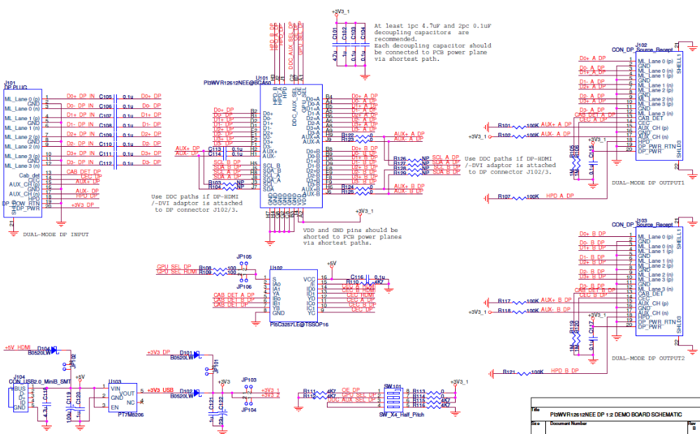

Figure 10: DP Section of PI3WVR12612 Demo Board Rev.B

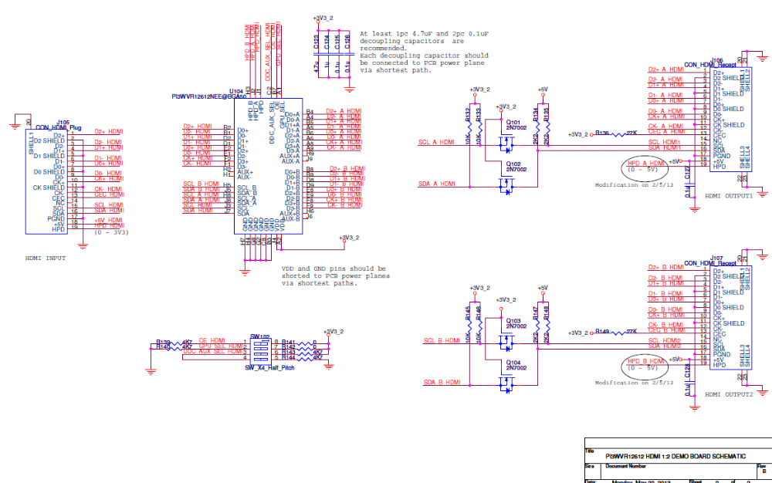

Figure 11: HDMI Section of PI3WVR12612 Demo Board Rev.B
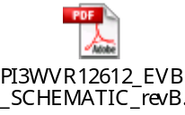For clearer view of schematic diagram, please click the PDF file icon on the right.

