Verification of PI3USB42 33V IBIS model
Introduction:
To verify the correlation between the ibis model and hspice model, we need to do some simulations:
PI3USB42

VOUT

SCL_C
SDA_C
R

SCL_C
SDA_C
D-

SCL_C
SDA_C
C

SCL_C
SDA_C
Input Signals

SCL_C
SDA_C
VIN

SCL_C
SDA_C
D-A

SCL_C
SDA_C
…..

SCL_C
SDA_C
D+

SCL_C
SDA_C
VIN

SCL_C
SDA_C
VOUT

SCL_C
SDA_C
R

SCL_C
SDA_C
C

SCL_C
SDA_C
D+A

SCL_C
SDA_C
The frequency of signal is 100MHz:
vinn dn 0 pulse ( 0 2 0 0.1n 0.1n 4.9n 10n )
vinp dp 0 pulse ( 2 0 0 0.1n 0.1n 4.9n 10n )
Add 100Ω pull-down resistor and 10pF pull-down capacitance to the output;

- SWITCH1：
- Simulation without package data:
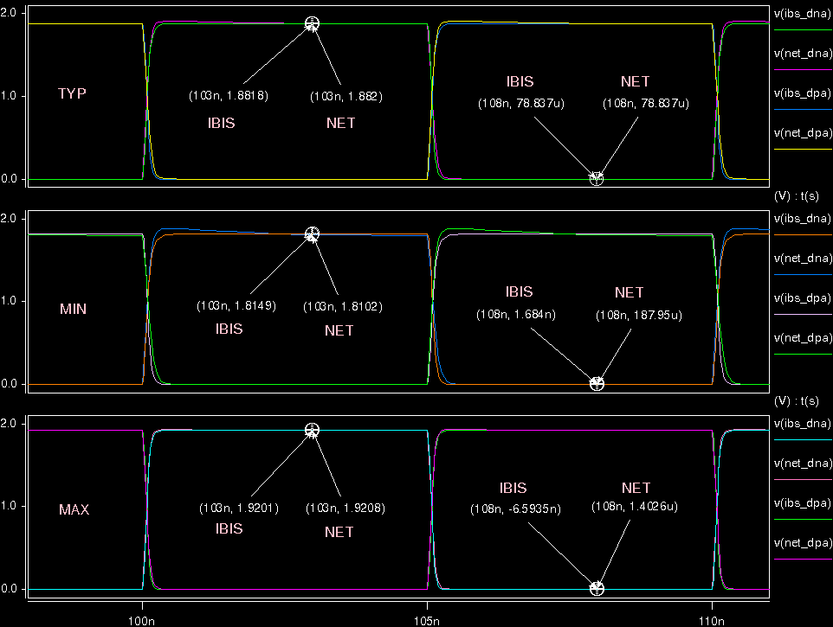

- Simulation with package data(NEW):
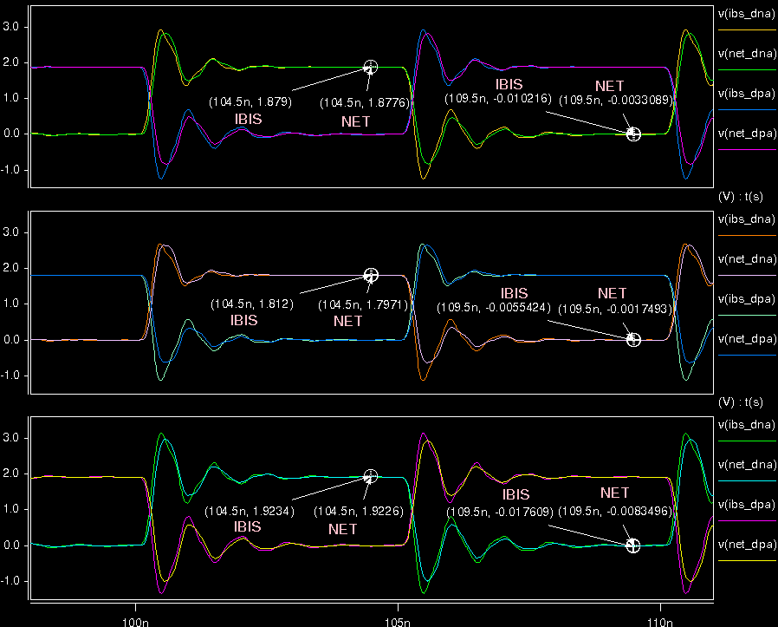
- Simulation with package data(OLD):
