Verification of PI3USB223 IBIS model
- Introduction:
To verify the correlation between the ibis model and hspice model, we need to do some simulations:
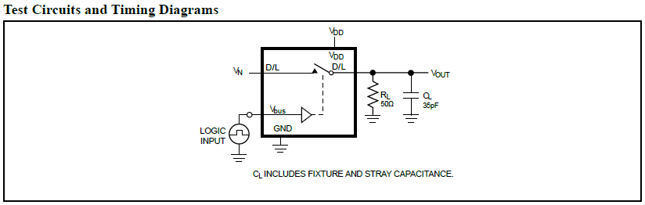
- SWITCH1: from USB input (D+, D-) to common terminal (D+/R, D-/L)
The frequency of signal is 1GHz:
vin1 pindp 0 pulse ( 0 1 0 .05n .05n .45n 1n)
vin2 pindn 0 pulse ( 1 0 0 .05n .05n .45n 1n)
- Add 50Ω pull-down resistors and 10pF pull-down capacitance to OUTPUT;

- SWITCH2: from audio input (R, L) to common terminal (D+/R, D-/L)
The frequency of signal is 1GHz:
vin1 pinr 0 pulse ( 0 1 0 .05n .05n .45n 1n)
vin2 pinl 0 pulse ( 1 0 0 .05n .05n .45n 1n)
- Add 50Ω pull-down resistors and 10pF pull-down capacitance to OUTPUT;

- Conclusion:
- For SWITCH1 and SWITCH2, the simulation results of IBIS model can match very well with the HSPICE model at different load conditions.

- Simulation Result:
- SWITCH1: from USB input (D+, D-) to common terminal (D+/R, D-/L)
PI3USB223
OUT0
OUT1
RCL_C
SDA_C
R
D+
C
C
Differential Signals
Output
D-
······

·
·
·

······

·
·
·

D+/R
D-/L
IN0
IN1
- Add 50Ω pull-down resistors and 10pF pull-down capacitance to OUTPUT;
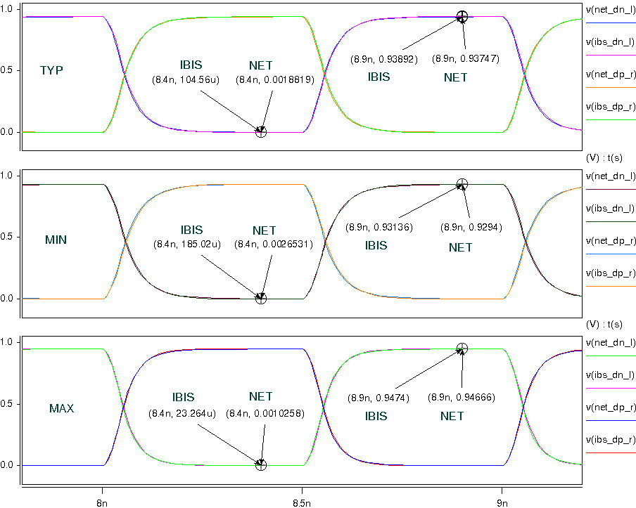

- SWITCH2: from audio input (R, L) to common terminal (D+/R, D-/L)
PI3USB223
OUT0
OUT1
RCL_C
SDA_C
R
R
C
C
Differential Signals
Output
L
······

·
·
·

······

·
·
·

D+/R
D-/L
IN0
IN1
- Add 50Ω pull-down resistors and 10pF pull-down capacitance to OUTPUT;
