PI3HDX412B and PI3HDX414

HDMI Splitter Selection Guide

Table of Contents

1 Introduction 2

2 Selection between PI3HDX412B and PI3HDX414 2

2.1 Supportive Data Rate 2

2.2 Source Termination 2

2.3 TMDS Pin Assignment 2

2.4 Squelch Feature 3

2.5 Input Termination 3

3 Settings of PI3HDX412B and PI3HDX414 3

3.1 EQ, Swing and Pre-emphasis via Pin Control Mode 3

3.2 EQ, Swing and Pre-emphasis via I2C Control Mode 4

4 Sink Application Schematic 5

4.1 Splitter Mode Activation 6

4.2 Primary Port Selection 6

4.3 TMDS Connection 6

4.4 DDC and HPD Connections 6

4.5 HDCP Authentication 6

5 Layout Recommendation 6

# 

# Introduction

Splitters with re-driving function are getting more popular in Wall TV, Signage or Splitter Box, etc. Pericom PI3HDX412B 1:2 active HDMI switch and PI3HDX414 1:3 active HDMI switch offer splitter function for transmitting up to 3.4Gbps TMDS signals from one source device to two or four sink devices at a time. Input equalization, output swing and output pre-emphasis can be adjusted via device pins or I2C control. A reference design of 1:2 splitter feature in sink application is described in this application note.

# Selection between PI3HDX412B and PI3HDX414

PI3HDX412B is a common choice to split TMDS signals into two paths in Wall TV and Signage applications. PI3HDX414 can be used to split TMDS signals into two, three or four paths. Thus, it is popular in Splitter Box design and large display of Wall TV or Signage.



PI3HDX412B offers three different configurations for individual customers’ designs.

|  |  |  |  |  |
| --- | --- | --- | --- | --- |
| Features | PI3HDX412BO | PI3HDX412BD | PI3HDX412BE | PI3HDX414 |
| Supportive Data Rate | 2.25Gbps | 3.4Gbps | 3.4Gbps | 3.4Gbps |
| Source Termination | NO | YES | YES | YES |
| TMDS Pin Assignment | D2  D1  D0  CLK | D2  D1  D0  CLK | CLK  D0  D1  D2 | D2  D1  D0  CLK |
| Squelch Feature | NO | YES | YES | YES |
| # Output Port | 2 | 2 | 2 | 4 |
| # Input Port | 1 | 1 | 1 | 1 |
| Input Termination | YES | YES | YES | YES |

Table 1: PI3HDX412B and PI3HDX414 Comparison Table



# Supportive Data Rate

As data rate is ramping up, source termination is implemented in PI3HDX412BD/E and PI3HDX414. Source termination can effectively terminates any mismatch from device’s input side. With the source termination, PI3HDX412BD/E and PI3HDX414 can support up to 3.4Gbps. PI3HDX412BO can be considered if data rate is up to 2.25Gbps only.



# Source Termination

Source termination can be enabled via ROUT_SEL of PI3HDX412BD/E and PI3HDX414 in pin control mode or through I2C control mode.

When the source termination of PI3HDX414 is enabled, high swing and high pre-emphasis are not recommended due to a small device package. Or otherwise, high current will be drawn through the source termination and the device temperature will increase. 500mV swing and 0dB pre-emphasis are recommended when the source termination is set.



# TMDS Pin Assignment

As PI3HDX412BD/E and PI3HDX414 carry squelch function, TMDS clock and data channels cannot be swapped. Since PI3HDX412B is widely used in splitter design, Pericom offer two pin assignments to provide flexibility to users. The pin assignment of PI3HDX412BD may be more preferable when being connected to a source chipset while the pin assignment of PI3HDX412BE is to sink scalar.

As PI3HDX412BO does not support squelch function, its TMDS clock and data channels are swappable, and it can be used in both source and sink applications.



# Squelch Feature

To ensure noise will not pass through when there is no input signal, TMDS outputs of PI3HDX412BD/E or PI3HDX414 will be disabled via squelch feature if no incoming TMDS clock is detected. Squelch feature is enabled at default. It can be disabled via I2C byte 1.

# Input Termination

PI3HDX412B and PI3HDX414 can accept AC coupled as well as DC coupled TMDS signals. When input is a dual-mode DP signal, input termination should be pulled to GND if there is any. At default, input termination is disabled. On the contrary, when input is an HDMI signal, input termination should be pulled to VDD if there is any. The input termination can be enabled and set to GND/VDD via I2C bye 1 bits 5 and 6, respectively.

# Settings of PI3HDX412B and PI3HDX414

Equalization, Output Swing and Output Pre-emphasis of PI3HDX412B and PI3HDX414 can be controlled via two modes – pin control and I2C control. MS pin is used to select the desired mode. If MS pin is set to high, I2C control is active. SCL_CTL and SDA_CTL are used for I2C transaction. ADR[3:0] are to set the I2C address. If MS pin is set to low, pin control mode is active. SW[2:1] and EMP[2:1] are used to control output swing and pre-emphasis settings. EQ[2:1] pins are used to control input equalization setting.

# EQ, Swing and Pre-emphasis via Pin Control Mode

The settings of input equalization, output swing and output pre-emphasis can be referred to the tables in the pin descriptions of Pericom datasheet or the tables shown below.

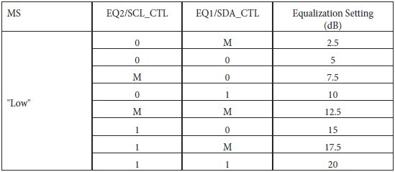

Table 2: Equalization Setting via Pin Control

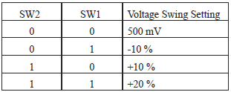

Table 3: Swing Setting via Pin Control

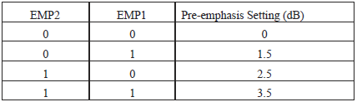

Table 4: Pre-emphasis Setting via Pin Control

# EQ, Swing and Pre-emphasis via I2C Control Mode

ADR[3:0] are used to set I2C address as below.



Table 5: I2C Address Byte

The settings of input equalization, output swing and output pre-emphasis for input port and output ports are referred to I2C Register Description on Pericom datasheet.



Table 6: Equalization Setting via I2C Control



Table 7: Swing and Pre-emphasis Settings via I2C Control

# Sink Application Schematic

Apart from number of output ports, PI3HDX412B and PI3HDX414 perform the same. A reference design of PI3HDX412BE splitter in sink application is shared below. Pin control mode is used in the reference design. Same idea applies to PI3HDX414 design.



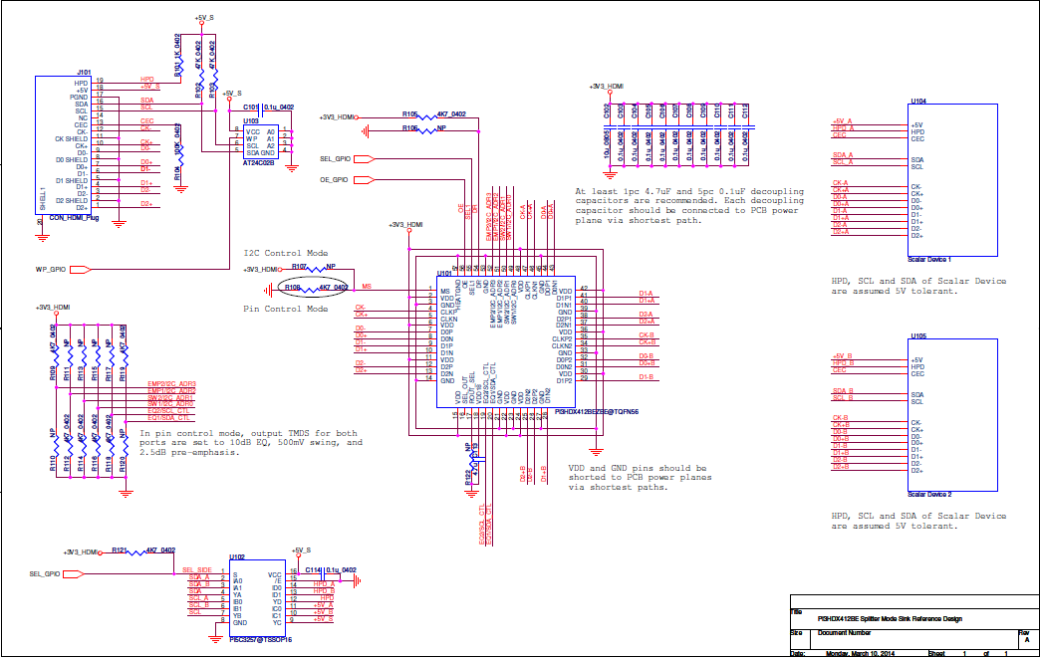

**Figure 1: PI3HDX412BE Splitter Sink Reference Design**



# Splitter Mode Activation

In order to enable splitter mode of PI3HDX412BE, DR at pin 54 should be set to high if using pin control mode. Alternatively, both ports can be enabled via I2C byte 0 if using I2C control mode.

# Primary Port Selection

Although splitter mode is enabled, SEL1 at pin 55 of PI3HDX412BE is still active to select a primary output port. S pin at pin 1 of PI5C3257 is in synchronized with the SEL1 pin of PI3HDX412BE. Input source will read the EDID content of the primary sink device and deliver video signals of the highest supportive timing of the primary sink device to both output ports. Thus, the two sink devices should accept the same timings. If the two sink devices are with different highest supportive timings, a timing format that both sink devices can support should be stored in the EEPROM at reference U103.

# TMDS Connection

TMDS signals are delivered to the selected port at the highest supportive timing of the selected sink device and multi-casted to the de-selected port.

# DDC and HPD Connections

As PI3HDX412BE does not carry switches for sideband signals, DDC and HPD signals are de-multiplexed through PI5C3257 in the reference design. Port selection of PI5C3257 is aligned with that of PI3HDX412BE.

HPD signals can pass through PI3HDX414. As the HPD of PI3HDX414 is not 5V tolerant, a series 25kΩ resistor between any HDMI connector and the HPD input pin of PI3HDX414 is recommended. For DDC switching among four ports, PI3USB14-A can be considered.

# HDCP Authentication

HDCP engine is not implemented in PI3HDX412BE. Thus, HDCP encryption and decryption must be handled by other devices.

# Layout Recommendation

As up to four ports of PI3HDX414 can be active at the same time, thermal pad must be designed carefully. Below are the recommendations:

1. Thermal pad size: 6x6mm on top and 10x10mm on bottom.
2. Number of vias: 36 thermal vias on 6x6mm thermal pad.
3. Via dimensions: diameter 0.3mm and pitch 1.0mm.
4. Cu trace thickness: 2oz on top and on bottom.
5. Cu plane thickness: 1oz.

Heat sink can also be added to PI3HDX414 for better temperature control.