PI3HDMI412AD
PI3HDMI412AD Demo Board User Manual
by Shengjiang Pan

Table of Contents

1 Introduction 2
2 Overview 2
3 Quick Start 4
4 Detailed Description 5
5 Appendix A: PI3HDMI412AD Demo Board Schematic 10
6 Appendix B: BOM List 11

Introduction
Pericom PI3HDMI412AD is a 1:2 active HDMI switch to drive differential signals to multiple video display units. Input equalization, output swing and output pre-emphasis for both output ports of PI3HDMI412AD can be adjusted via device pins or I2C control. When using PI3HDMI412AD as switch or splitter, cascading PI3HDMI412AD is not suggested in application.

PI3HDMI412AD demo board is designed to demonstrate the performance and key features of PI3HDMI412AD. This user manual describes how to use this demo board. It will be divided into following sections:

- Overview
- Quick Start
- Detail Description

Overview
Figure 1 is the block diagram of Pericom PI3HDMI412AD demo board and Figures 2 is the top view of Demo board. As shown in figure 1, PI3HDMI412AD is used to transmit TMDS signals while side band signals are transmitted by PI5C3257. When PI3HDMI412AD works in I2C mode, JP4 and JP5 are I2C interface to configure PI3HDMI412AD registers. This demo board is powered by +5V DC from mini USB female connector (J4).

J3
PI3HDMI412AD
J2
Output
Port B
Output
Port A
HDMI
Input
TMDS
J1
J4
PI5C3257
Output
Port B
Output
Port A
Side Band
Input
Mini USB Connector
U3
TMDS A
TMDS B
3.3V
Regulator
JP4
JP5
Side Band A
Side Band B
SCL/S3
SDA/S2
HDMI Input
Connector
Port A HDMI
Connector
Port B HDMI
Connector
Figure 1: Block Diagram of PI3HDMI412AD Demo Board
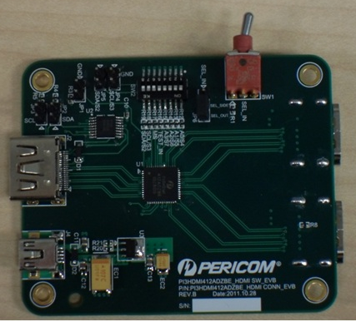
Figure 2: Top View of PI3HDMI621 Demo Board
Port A
Port B

Quick Start
As PI3HDMI412AD can work at I2C control mode and Pin control mode, here Pin control mode is chosen to start up the PI3HDMI621 demo board, complete the following steps:
- Supply 5V to demo board from USB Connector at J4;
- Set MS(pin) low and make PI3HDMI412AD into Pin control mode through SW2
- Set JP1 open to make OE pin high so that PI3HDMI412AD can be enabled;
- Set Swing, Pre-emphasis, EQ to 500mV,0dB and 1dB respectively through SW2;
- Set SEL_out low to Select Output HDMI output port A through SW1;
- Set JP6 connect to SEL_in;
- Connect Sources, e.g. DVD players, to HDMI Input Connectors at J2
- Connect Sink, e.g. HDTV, to HDMI Output Connector J1;

JP1 | JP2 | JP3 | JP4 | JP5 | JP6 | SW1 (S1)
Open | Open | Open | Open | Open | Short Pin 1&2 | Low
Table 1: Jumpers Connection at Quick Start

A0/S4 | A1/S5 | A2/S6 | A3/S7 | TEST_IN | MS | SCL/S3 | SDA/S2
Low | Low | Low | Low | Low | Low | Low | Low
Table 2: SW2 Connection at Quick Start

Detailed Description
The functionality of Jumpers, switches and key circuits are described in detail in this section.

  - Functionality of Jumpers & Switches

Jumper | Description
JP1 | OE: output Enable  Short: Output is disabled;  Open: Output is enabled.
JP2 | Short: Pull-up resistors of DDC are connected at source side.  Open: Pull-up resistors of DDC are disconnected at source side.
JP3
JP4 | In I2C control mode, JP4 (SCL) and JP5 (SDA) are for I2C interface connection.
JP5
JP6 | Control of side band signals  Short Pin 1&2 when PI3HDMI412AD is in Pin control mode.  Short Pin 2&3 when PI3HDMI412AD is in I2C control mode.
SW1 | When PI3HDMI412AD is in Pin control mode,  Low: Port A is selected;  High: Port B is selected;
SW2 | SW2 is used to configure PI3HDMI412. In pin control mode, EQ, Vswing, pre/de-emphasis can be configured through SW2; in I2C control mode, address of PI3HDMI412AD can be set through SW2.
Table 3: Function of Jumpers and Switch

  - Key Circuits Description

- PI3HMDI621 demo board can be supplied through Mini-USB adaptor J4.
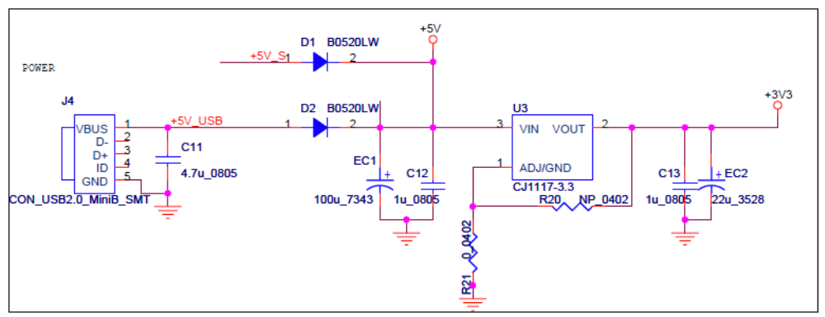
Figure 5: Power Circuit

- Side band signals are switched using PI5C3257. When PI3HDMI412AD is in Pin control mode, pin 1 and 2 of JP6 should be shorted; otherwise, pin 2 and 3 of JP6 should be shorted.

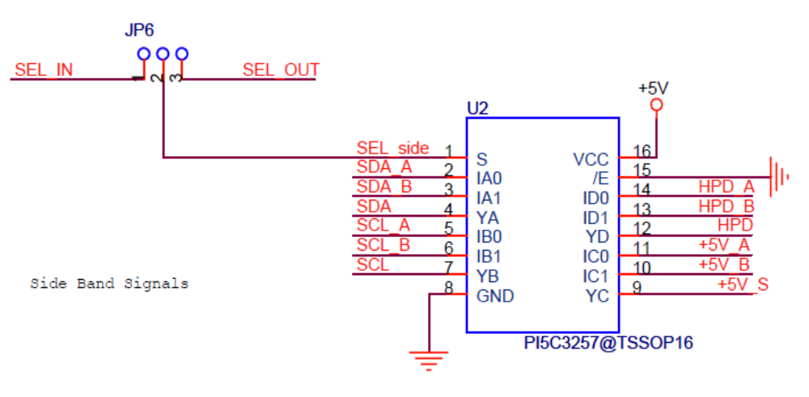
Figure 6: Side Band Circuit

- When PI3HDMI412AD is in I2C control mode, Pins: SCL/S3, SDA/S2 are used as I2C interface pins. Please be reminded that SCL/S3 and SDA/S2 should be pulled up as JP4(SCL) and JP5(SDA) are used to connect I2C adapter to configure registers of PI3HDMI412AD.

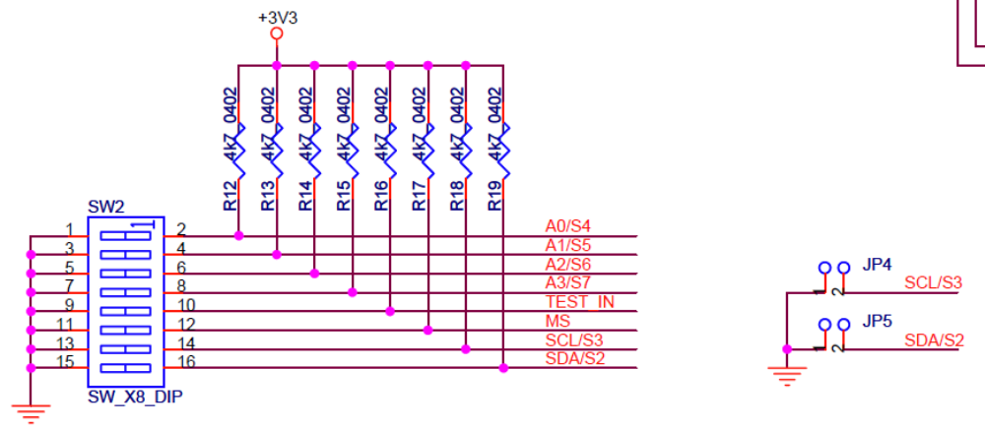
Figure 7: SW2 and I2C Circuit

- When DDC is connected from chipset, DDC may need to be pulled up to 3.3V externally.JP2 and JP3 are reserve for it.
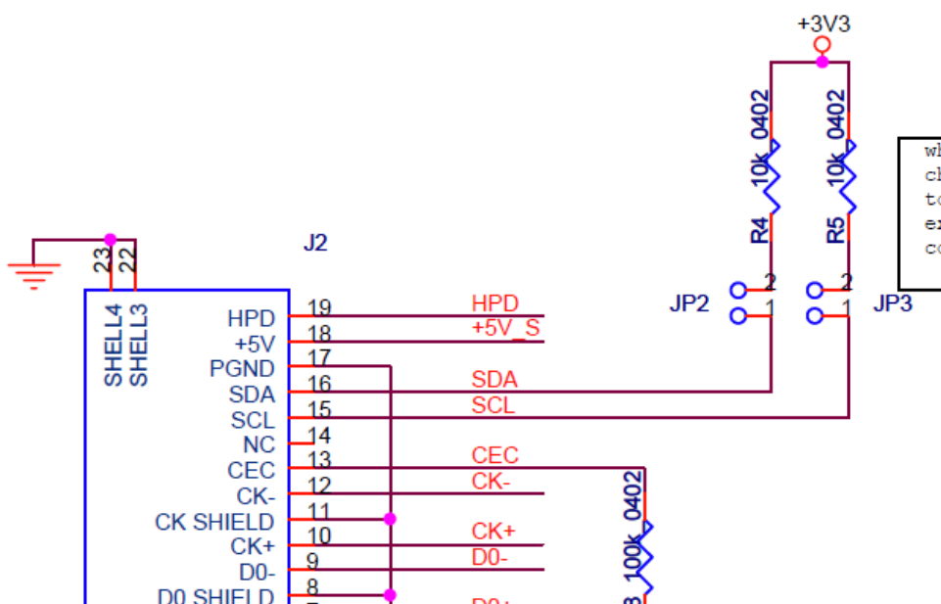
Figure 8: DDC Pull-up Resistor at Source

- SW2 is used to configure PI3HDMI412AD. All the control bits can be set to high or low through SW2. For more details about SW2, please refer to table 4.
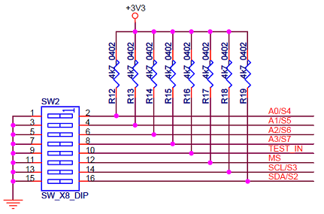
Figure 9: Circuit of SW2

SW2  Switch# |  | Pins |  | Description
1 | A0/S4 |  | A0~A3 are address pin when PI3HDMI412AD is in I2C control mode.  S4~S7 are Vswing and pre/de-emphasis pins of PI3HDMI412AD.
2 | A1/S5
3 | A2/S6
4 | A3/S7
5 |  | MS |  | Mode Selection Pin  Low: Pin control mode  High: I2C control mode
6 |  | TEST_IN |  | Low: Normal operation  High: Internal testing
7 |  | SCL/S3 |  | When MS is low, these two pins are used as EQ setting pins  When MS is high, these two pins are used as I2C interface.
8 |  | SDA/S2
Table 4: Function of SW2

  - Configuration of PI3HDMI412AD
As PI3HDMI412AD can work at pin control mode and I2C control mode, EQ, Vsing, pre/de-emphasis or other can be adjusted through corresponding pins or bits of I2C registers.

- EQ can be adjusted through S3 and S2. For general source application, EQ is suggested to set 1dB or 3.5dB to avoid over-EQ.
S3 | S2 | Setting
0 | 0 | 1dB
0 | 1 | 3.5dB
1 | 0 | 6dB
1 | 1 | 8dB
Table 5: EQ Setting

- Vswing and Pre/de-emphasis can be adjusted through S7, S6, S5 and S4. For general source application, Vswing and Pre-emphasis are suggested to set 500mV and no more 1.5dB respectively to pass VL test.
S7 | S6 | S5 | S5 | Setting
0 | 0 | 0 | 0 | 500mV, 0dB Pre/de-emphasis
0 | 0 | 0 | 1 | 750mV, 0dB Pre/de-emphasis
0 | 0 | 1 | 0 | 1000mV, 0dB Pre/de-emphasis
0 | 1 | 0 | 0 | 500mV, 0dB Pre/de-emphasis
0 | 1 | 0 | 1 | 500mV, 1.5dB Pre-emphasis
0 | 1 | 1 | 0 | 500mV, 3.5dB Pre-emphasis
0 | 1 | 1 | 1 | 500mV, 6.0dB Pre-emphasis
1 | 0 | 0 | 0 | 750mV, 0dB Pre/de-emphasis
1 | 0 | 0 | 1 | 750mV, -1.5dB de-emphasis
1 | 0 | 1 | 0 | 750mV, -3.5dB de-emphasis
1 | 0 | 1 | 1 | 750mV, -6dB de-emphasis
Table 6: Vswing, Pre/de-emphasis Settings

- Splitter Mode Configuration
When PI3HDMI412AD works in pin control mode and Test_in pin of PI3HDMI412 should be tied to high voltage, PI3HDMI412AD can go into splitter mode.

When PI3HDMI412AD works in I2C control mode and Byte 3 bit1 should be set to high, PI3HDMI412AD can go into splitter mode.

Appendix A: PI3HDMI412AD Demo Board Schematic
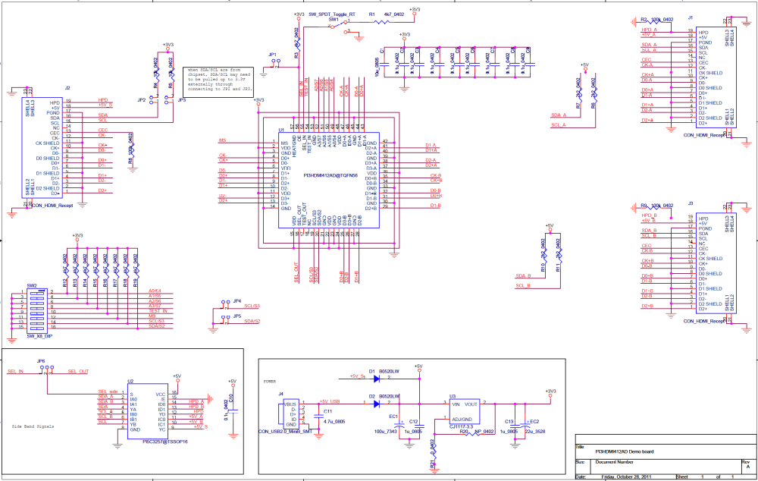

For more clear on viewing the schematic diagram, please click on this icon to open the PDF file.
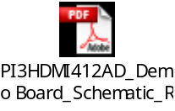

Appendix B: BOM List

Item | Quantity | Reference | Description
1 | 9 | C2, C3, C4, C5, C6, C7, C8, C9, C10 | 0.1uF Capacitor
2 | 2 | C12, C13 | 1uF Capacitor
3 | 1 | C11 | 4.7uF Capacitor
4 | 1 | C1 | 10uF Capacitor
5 | 1 | EC2 | 22uF Capacitor
6 | 1 | EC1 | 100uF Capacitor
7 | 2 | D1, D2 | B0520LW Schottky Rectifier
8 | 5 | JP1, JP2, JP3, JP4, JP5 | 2-Pin Headers
9 | 1 | JP6 | 3-Pin Headers
11 | 1 | J4 | Mini USB Female Connector
12 | 3 | J1, J2, J3 | HDMI Type A Receptacle Connector
13 | 4 | R6, R7, R10, R11 | 2.2kΩ Resistor
14 | 10 | R12, R13, R14, R15, R16, R17, R18, R19, R1, R3 | 4.7 kΩ Resistor
16 | 2 | R4, R5 | 10kΩ Resistor
17 | 3 | R2, R8, R9 | 100kΩ Resistor
19 | 1 | U1 | PI3HDMI412AD
20 | 1 | U2 | PI5C3257
21 | 1 | U3 | 1117 Regulator
23 | 1 | SW1 | SW_SPDT_Toggle
24 | 1 | SW2 | SW_X8_DIP

