PI3HDMI301
2-Layer Demo Board Rev.A User Manual
by Ada Yip

Introduction
This user manual describes the components and the usage of PI3HDMI301 2-Layer HDMI-HDMI Demo Board Rev.A. To be more cost effective, 2-layer instead of 4-layer PCB is designed. As ground layer is not present in 2-layer PCB, reference ground has to be ensured continuous. Closer view of layout next to PI3HDMI301 is attached in Appendix C.

- Overview
- Quick Start
- Detailed Description
- Test Result

Overview
Figure 1 is the block diagram of Pericom PI3HDMI301 2-Layer Demo Board and Figures 2a and b show the top and bottom views of the demo board. There are three HDMI Type A receptacle connectors (J301-3), which are used to connect to HDMI source devices, such as DVD players. The HDMI Type A plug connector (J304) is used to connect to an HDMI sink device, such as HDTV. The demo board can be powered up by +5V DC from mini USB female connector (J306) or by delivering the 5V power of source to 3.3V regulator (U302). Swing, pre-emphasis and equalization of PI3HDMI301 can be adjusted using an 8-pin switch (SW301). A DP3T switch (SW302) is used to select HDMI port among ports 1, 2 and 3. The EEPROMs, which are used to model the DDC capacitance of EEPROMs in sink device, are optional and are not assembled on the demo board.
J301
PI3HDMI301
J304
U304
3.3V
Regulator
J306
Mini USB Connector
Input Port 2
Input Port 3
U302
SW301
8-pin Switch
SW302
DP3T Switch
2”
6”
4”
Input Port 1
J303
J302
2”
U303
U305
HDMI Input Connectors
HDMI Output Connector
EEPROM (Optional)
Figure 1: Block Diagram of PI3HDMI301 2-Layer Demo Board

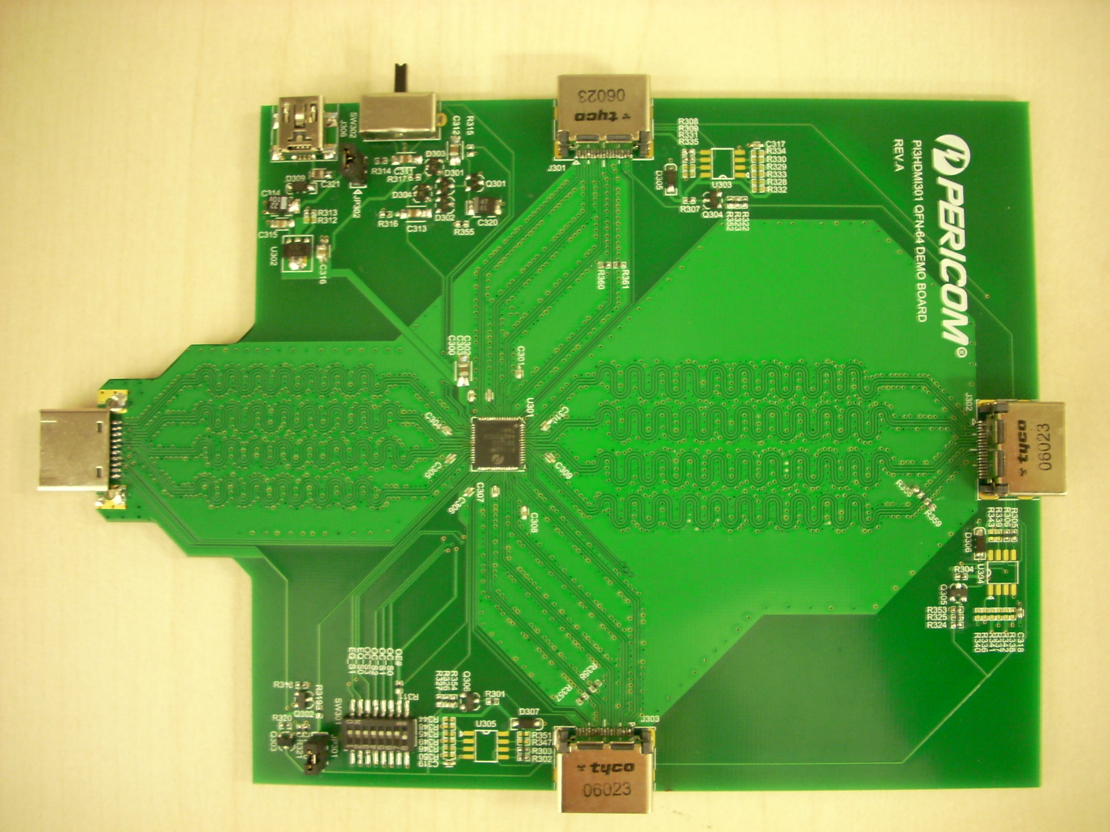
Figure 2a: Top View of PI3HDMI301 2-Layer Demo Board

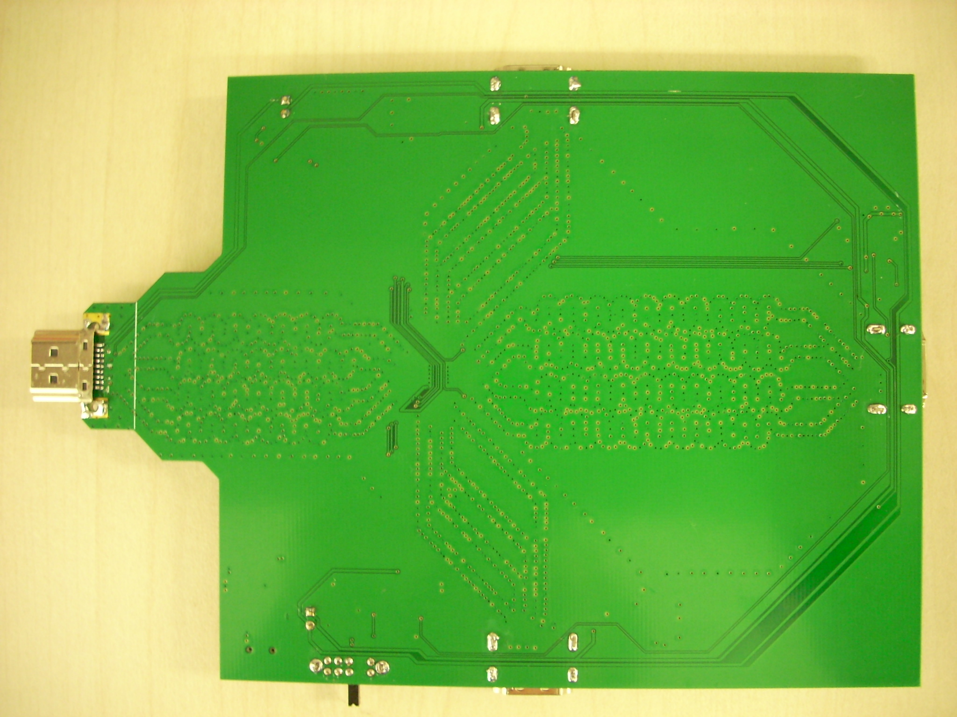
Figure 2b: Bottom View of PI3HDMI301 2-Layer Demo Board
Quick Start
To start-up the PI3HDMI301 2-Layer Demo Board, complete the following steps:
- Short /OE pin to GND using second last pin of SW301 8-pin switch in order to enable PI3HDMI301;
- Set Swing and Pre-emphasis to 500mV and 0dB, respectively, using pins 3-6 of SW301 switch;
- Set optimum EQ settings using pins 1-2 of SW301 switch regarding to Table 1;
- Place jumper at JP301 to provide 5V to Sink;
- Supply 5V to demo board from USB Connector at J306 or get the 5V power from Source by shorting JP302;
- Connect Sources, e.g. DVD players, to HDMI Input Connectors at J301, 302 and/or 303;
- Connect Sink, e.g. HDTV, to HDMI Output Connector at J304;
- Select desired HDMI port using SW302 DP3T switch.

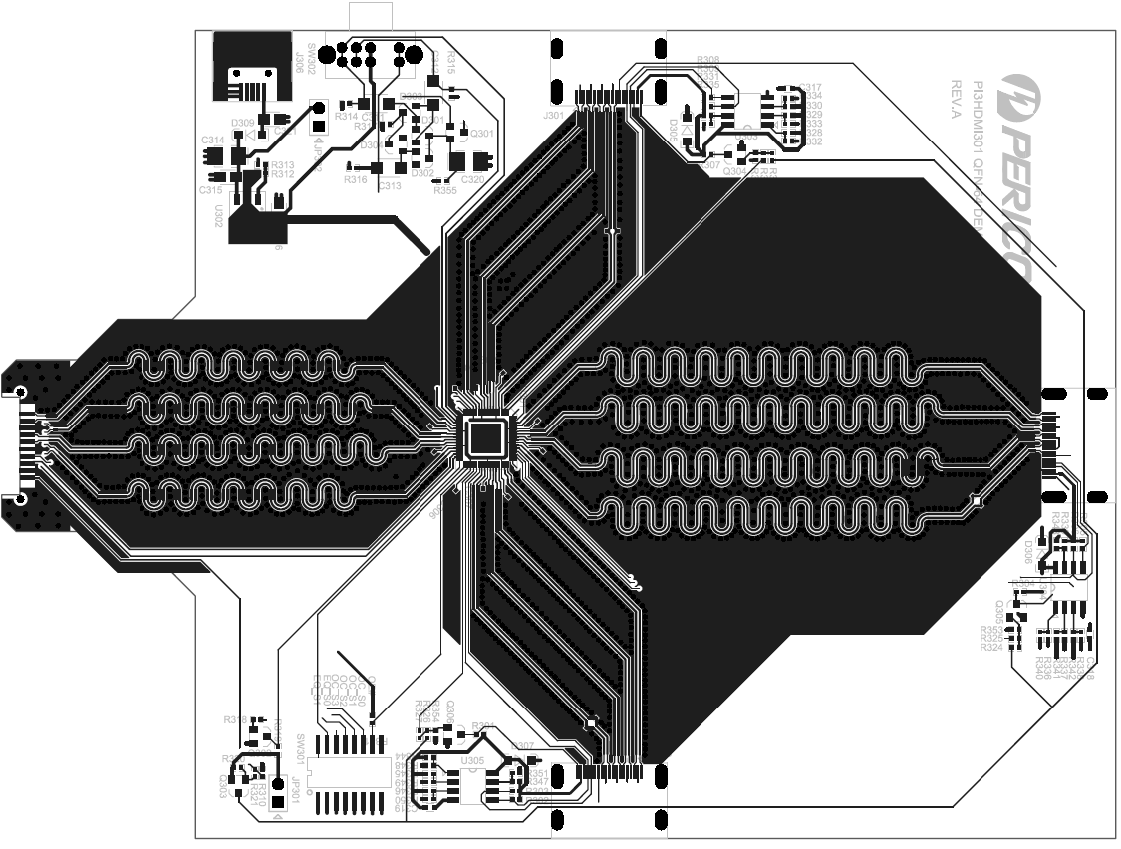
Figure 3: Layout of PI3HDMI301 2-Layer Demo Board (Top View)

Equalization | Input Trace
3 dB | 4 – 8”
8 dB | 8 – 16”
12 dB (Optimized) | 12 – 18”
15 dB | 16 – 24”
Table 1: Optimized EQ Setting in Sink Application
Detailed Description
- An HPD pulse of 250ms is generated at HPD_D3_1 pin when switching port via switch SW302 in the following circuit. This pulse is sent back to HPD_SINK pin of PI3HDMI301 to introduce an HPD reset signal.

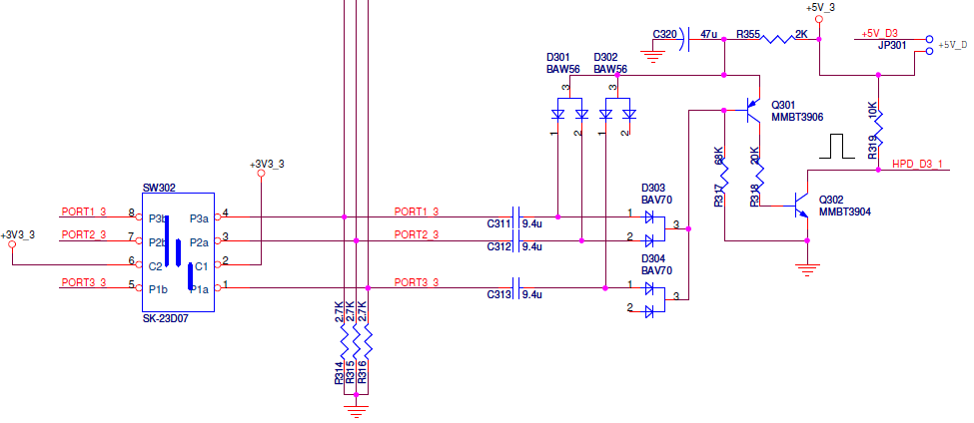
Figure 4: HPD Reset Pulse Circuit

The pulse will be delivered to the HPD pin of one selected port among three, HPD_A3_1, HPD_B3_1 or HPD_C3_1. This pulse will then initiate a reset of HPD at input connector side, HPD_A3, HPD_B3 or HPD_C3, through NPN transistor, Q304, Q305 or Q306, respectively. The reset circuit of port 1 is shown below. Resetting HPD is to ensure that HDCP Transmitter Link State is reset back to reset state H0. For details, please refer to Application Note AN202.

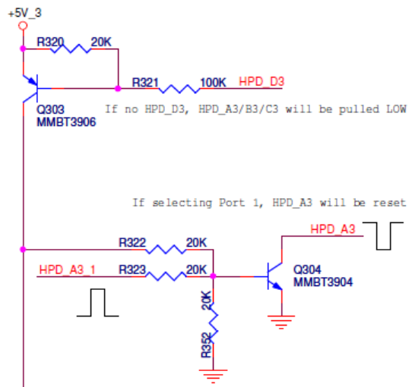
Figure 5: Source HPD Reset

- If Sink receiver is not connected to HDMI connector J304, HPD_D3 pin will become low. As shown in the above figure, the low HPD_D3 will turn on PNP transistor Q303 and then three NPN transistors Q304, Q305 and Q306. As a result, all the HPD signals at source side are pulled low and reset to state H0.

- When source chipset does not generate CLK signal, noise may pass through an active PI3HDMI301 to cause output oscillation. To implement fail-safe feature to prevent from output oscillation, the input CLK is recommended to be biased externally. 100mV DC bias can be added to CLK+ by adding a 1.5kΩ pull-down resistor. To maintain trace impedance consistency, it is recommended to avoid stub between pull-down resistor pad and CLK signal trace on PCB layout.

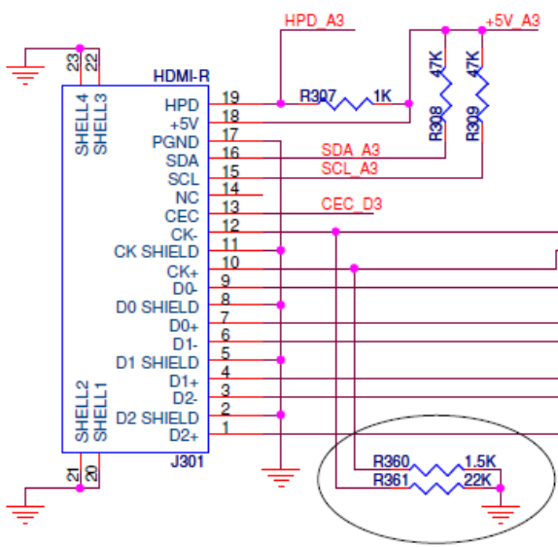
Figure 6: Input CLK External Pull-down

In some DVD players, no sink current circuitry is implemented in TMDS. When these DVD players are de-selected, CLK signals stay at high level. To ensure the DVD players can enter idle mode when being de-selected, input CLK+/- pins are pulled down externally. By keeping 1.5kΩ pull-down resistor at CLK+ unchanged, another 22kΩ resistor is added to CLK- to pull CLK to low level when there is no 50Ω termination. HDCP can then be reset by RxSense.
Test Result
- The eye diagram test in Test ID 7-10 of CTS is performed to determine the optimized EQ setting when 10m 28AWG HDMI cable is connected to J302, the input HDMI connector with 4” trace. A 1080p/60Hz, 8-bit Standard Color, Acer1 test pattern from Quantum Data is used as source. 500mV swing and 0dB pre-emphasis are chosen during the test. Output eye diagrams with different equalization settings are captured at TMDS D0 at HDMI output port (J304) of PI3HDMI301 2-Layer Demo Board.

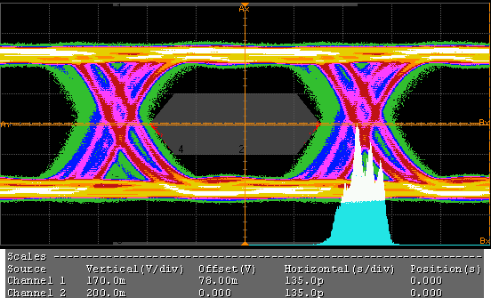
Figure 7: Eye Diagram of 3dB EQ with 10m Cable at Port 2
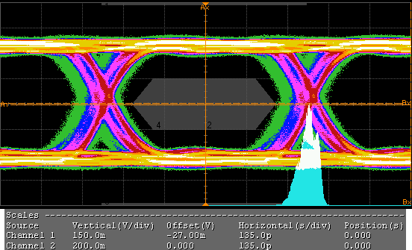
Figure 8: Eye Diagram of 8dB EQ with 10m Cable at Port 2

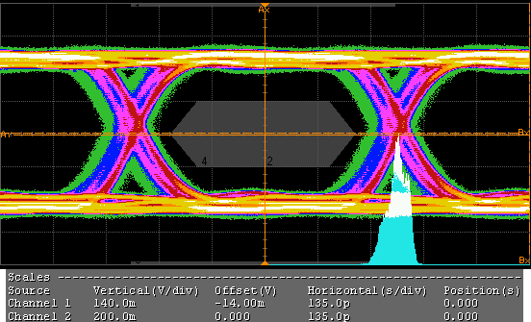
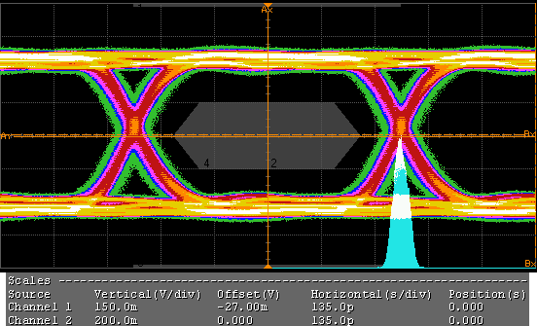

Figure 9: Eye Diagram of 12dB EQ with 10m Cable at Port 2
Figure 10: Eye Diagram of 15dB EQ with 10m Cable at Port 2

On top of HDMI source eye diagrams shown above, the data jitter values are documented to show that a passing source eye with 10m cable at input port 2 can be obtained for any equalization setting greater than 8dB. The source eye mask is just for reference for Sink Application.

Data Jitter
3dB EQ | 8dB EQ | 12dB EQ | 15dB EQ
0.350 T_{BIT} | 0.255 T_{BIT} | 0.226 T_{BIT} | 0.171 T_{BIT}
Table 2: Data Jitters with Different EQ Settings
- Termination Voltage in Test ID 8-4 is performed at J302 input HDMI connector.
Output | Vterm | Spec |  | Units
Output | Vterm | Min | Max
D2+ | 3.29 | 3.125 | 3.475 | V
D2- | 3.29 | 3.125 | 3.475 | V
D1+ | 3.29 | 3.125 | 3.475 | V
D1- | 3.29 | 3.125 | 3.475 | V
D0+ | 3.29 | 3.125 | 3.475 | V
D0- | 3.29 | 3.125 | 3.475 | V
CLK+ | 3.18 | 3.125 | 3.475 | V
CLK- | 3.28 | 3.125 | 3.475 | V
Table 3: Termination Voltage Result at J302

- Jitter Tolerance in Test ID 8-7 is performed when Data Generator is connected to J302 input HDMI connector and J304 output HDMI connector is attached to Philips 1080p HDTV.

Based on HDMI CTS 1.3c, 0.25*T_{BIT} C_JITTER and 0.3*T_{BIT} D_JITTER are set at Test Points TP1 (or 0.3*T_{BIT} C_JITTER and 0.5*T_{BIT} D_JITTER are set at Test Points TP2). Test setup below shows the locations of TP1 and TP2. Jitter Tolerance Test is performed when TMDS_CLOCK to TMDS_DATA skew is set to 0.0T_{BIT} to 1.0T_{BIT} with 0.1T_{BIT} step.
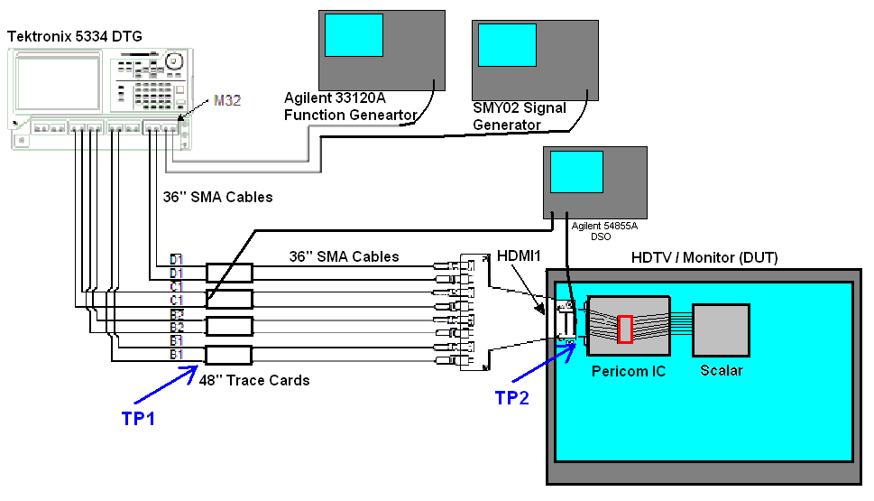
Figure 11: Jitter Tolerance Test Setup

Jitter Tolerance Test is performed at HDMI Connector J302 of PI3HDMI301 2-layer demo board at 1920x1080p, 60Hz refresh rate and 8-bit color rate.
C_JITTER (T_{BIT}) at TP1 | C_JITTER Freq. (MHz) | D_JITTER (T_{BIT}) at TP2 | D_JITTER Freq. (MHz) | Jitter Tolerance with CLK-DATA Skew = 0.0 to 1.0T_{BIT}
0.25 | 10.0 | 0.50 | 0.5 | Pass @0.0 to 1.0T_{BIT} Skew
0.30 | 10.0 | 0.60 | 0.5 | Pass @0.0 to 1.0T_{BIT} Skew
0.25 | 7.0 | 0.50 | 1.0 | Pass @0.0 to 1.0T_{BIT} Skew
0.30 | 7.0 | 0.60 | 1.0 | Pass @0.0 to 1.0T_{BIT} Skew
Table 4: Jitter Tolerance Result at J302
- TMDS Differential Impedance in Test ID 8-8 at each port is checked.
Port | Through Impedance | D2 | D1 | D0 | CLK | Spec |  | Units
 |  |  |  |  |  | Min | Max | Units
J301 | Min | 86 | 87 | 87 | 91 | 85 | 115 | Ω
J301 | Max | 108 | 104 | 105 | 104 | 85 | 115 | Ω
J302 | Min | 89 | 89 | 89 | 91 | 85 | 115 | Ω
J302 | Max | 107 | 104 | 105 | 104 | 85 | 115 | Ω
J303 | Min | 86 | 86 | 86 | 90 | 85 | 115 | Ω
J303 | Max | 106 | 103 | 105 | 104 | 85 | 115 | Ω
Table 5: TDR Result

- HPD Output Voltage and Resistance in Test IDs 8-10 and 11 are tested at J302 input HDMI connector.
Parameter | DUT Power | P_5V | V_{HPD} | Spec |  | Units
 |  |  |  | Min | Max | Units
V_{HPD_L} | Off | 0.0V | 0.00 | 0.0 | 0.4 | V
V_{HPD_L} | Standby | 0.0V | 0.00 | 0.0 | 0.4
V_{HPD_L} | On | 0.0V | 0.00 | 0.0 | 0.4 | V
V_{HPD_H} | On | 4.8V | 4.79 | 2.4 | 5.3 | V
V_{HPD_H} | On | 5.3V | 5.29 | 2.4 | 5.3 | V
Table 6: HPD Output Voltage Result at J302

Parameter | J302 | Spec |  | Units
Parameter | J302 | Min | Max | Units
V_{A} | 4.99 | NA | NA | V
V_{B} | 4.55 | NA | NA | V
Z_{HPD} | 967 | 800 | 1200 | Ω
Z_{HPD} = (V_{A}/V_{B} – 1) * 10,000
Table 7: HPD Output Resistance Result at J302

Appendix A: Test Equipments
- Agilent Power Supply
- Agilent 54855A DSO with 1134A 7GHz Probe System and E2675A Differential Solder-in Probe Heads
- TDS8000 Digital Sampling Oscilloscope
- Tektronix DTG5334 Data Timing Generator with DTG30 and DTG32 Modules
- Agilent 33120A Function Generator
- R&S SMY02 Signal Generator
- Philips 37PFL7422 1080p HDTV
- Pericom 48” Trace Cards (Modeling Cable Emulator)
- 36” SMA-SMA Cables
- Pericom SMA-to-HDMI Test Fixture
- Multimeter

Appendix B: PI3HDMI301 2-layer Demo Board Schematic
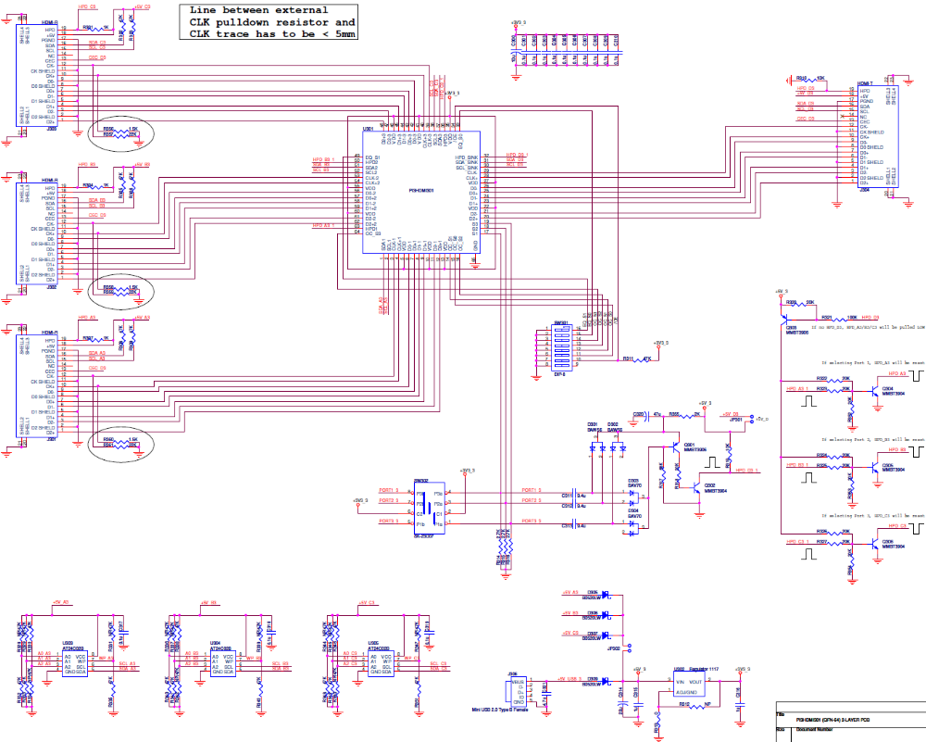
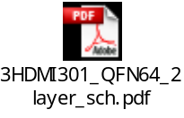For clearer view of schematic diagram, please click the PDF file icon on the right.

Appendix C: PCB Layout

Top View
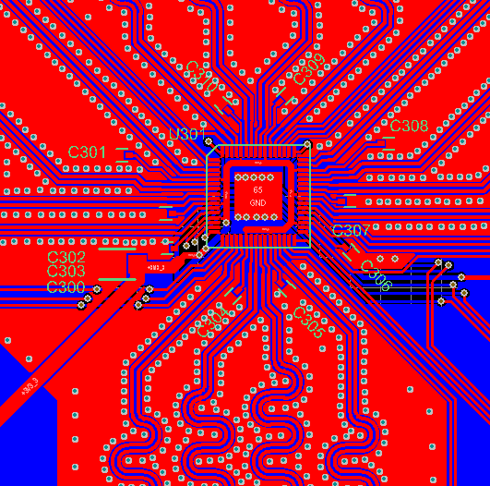

Bottom View
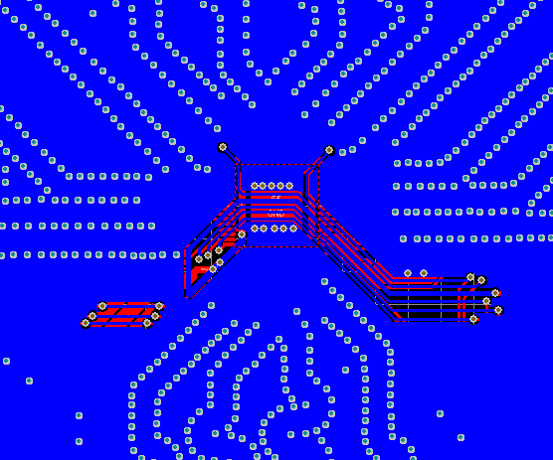
Appendix D: BOM List
Item | Quantity | Reference | Description
1 | 13 | C301, C302, C303, C304, C305, C306, C307, C308, C309, C310, C317, C318, C319 | 0.1uF Capacitor
2 | 1 | C314 | 22uF Capacitor
3 | 2 | C315, C316 | 1uF Capacitor
4 | 1 | C320 | 4.7uF Capacitor
5 | 4 | C300, C311, C312, C313 | 10uF Capacitor
6 | 1 | C320 | 47uF Capacitor
7 | 2 | D301, D302 | BAW56 Common Anode Double Diode
8 | 2 | D303, D304 | BAV70 Common Cathode Double Diode
9 | 4 | D305, D306, D307, D309 | B0520LW Schottky Rectifier
10 | 2 | JP301, JP302 | 2-pin Header
11 | 3 | J301, J302, J303 | HDMI Receptacle Connector
12 | 1 | J304 | HDMI Plug Connector
13 | 1 | J306 | Mini USB Female Connector
14 | 2 | Q301, Q303 | MMBT3906 PNP Transistor
15 | 4 | Q302, Q304, Q305, Q306 | MMBT3904 NPN Transistor
16 | 3 | R301, R304, R307 | 1kΩ Resistor
17 | 19 | R302, R303, R305, R306, R308, R309, R311, R330, R332, R333, R335, R338, R340, R341, R343, R346, R348, R349, R351 | 47kΩ Resistor
18 | 2 | R310, R319 | 10kΩ Resistor
19 | 1 | R313 | 0Ω Resistor
20 | 3 | R314, R315, R316 | 2.7kΩ Resistor
21 | 1 | R317 | 68kΩ Resistor
22 | 11 | R318, R320, R322, R323, R324, R325, R326, R327, R352, R353, R354 | 20kΩ Resistor
23 | 1 | R321 | 100kΩ Resistor
24 | 1 | R355 | 2kΩ Resistor
25 | 3 | R356, R358, R360 | 1.5kΩ Resistor
26 | 3 | R357, R359, R361 | 22kΩ Resistor
27 | 12 | R328, R329, R331, R334, R336, R337, R339, R342, R344, R345, R347, R350 | NOT CONNECTED
28 | 1 | SW301 | DIP-8 Switch
29 | 1 | SW302 | DP3T Switch
30 | 1 | U301 | PI3HDMI301 HDMI Switch
31 | 1 | U302 | 1117 Regulator
32 | 2 | U303, U304, U305 | AT24C02B EEPROM

