PI3EQX6741STZDE
Subject: PI3EQX6741STZDE ReDriver Application Evaluation Report

From: Lingsan

Date: 3/15/2011

Summary
- Phy Transmit Signal Requirement: TSG-01, TSG-02, TSG-03, TSG-04, OOB-02, OOB-03, OOB-04, OOB-05 are tested in Figure3 to Figure14.
- OOB signaling on/off time are checked in Figure15, PI3EQX6741ST can work with LSI card with normal OOB input/output in Figure16.
- Power consumption is measured in Table1 and one is in spec limitation of datasheet.
- Different eSATA HDD connection test are done and passed in Table2.
- Different internal HDD connection test are done and passed in Table3.
- PI3EQX6741ST can work for normal startup and reading/writing on Compal NB-PAL50 with Seagate HDD and other HDDs.

Part Information
Device Name: PI3EQX6741ST
Lots Number: N.A.
Part Marking: EQX6741STZDE JBHGC
Package: 20 pin TQFN (ZD)

Introduction
The report shows the performance of PI3EQX6741STZDE SATA3 ReDriver on evaluation board Rev.A. Figure1a&1b are top and bottom view of the board.
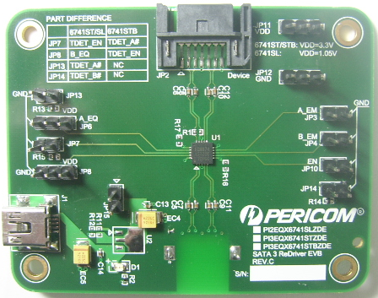
Figure1a. Top view of PI3EQX6741STZDE Eval Board Rev.A
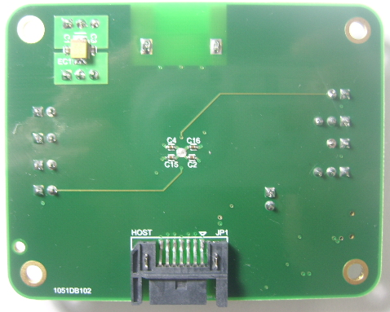
Figure1b. Bottom view of PI3EQX6741STZDE Eval Board Rev.A

Test Setup
There is test point on the board, TP1 for A_OUT and TP2 for B_OUT differential pair in Figure2
Control Signal Setting:
TDet_EN=LOW,
A_EM&B_EM=LOW
A_EQ&B_EQ=LOW
Test Equipment:
Agilent Infiniium 54855A Digital Sampling Oscilloscope
Agilent E2695A probe Head
Agilent E2677A probe Head
SATA test fixture
AMD mother board
Intel mother board
SIIG 6G SATA Card
External Hard Disk
Udisk with DOS system
SATA cable
Ru software for AMD BIOS setting
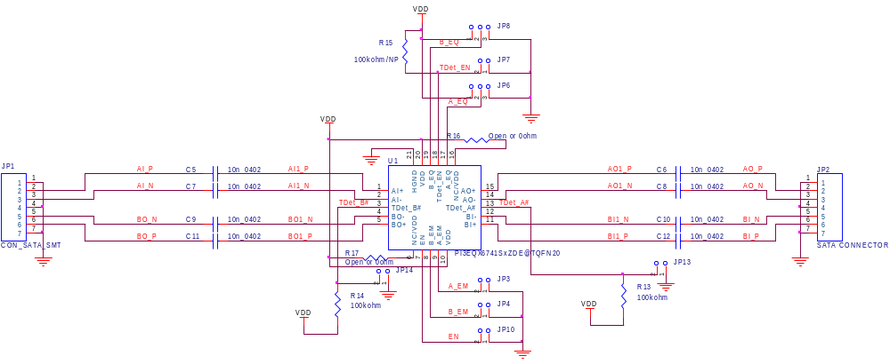
TP1
TP2
Figure2. Test Point Setting

Test Items and Result

- Unit Interval
Figure3 shows unit interval of Gen1 (1.5G) and Gen2 (3.0G). Test point is TP1.
UI for Gen1 (665.83) | UI for Gen2 (332.6ps)
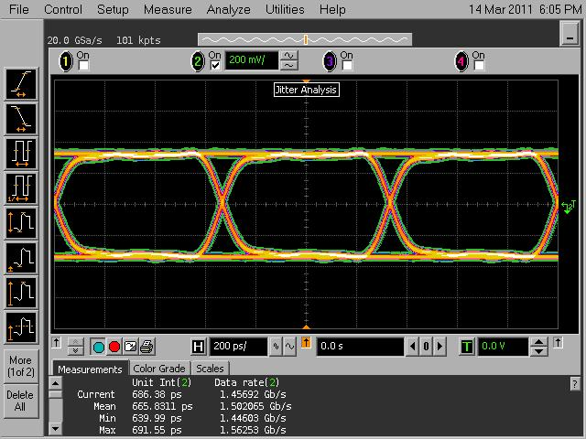 | 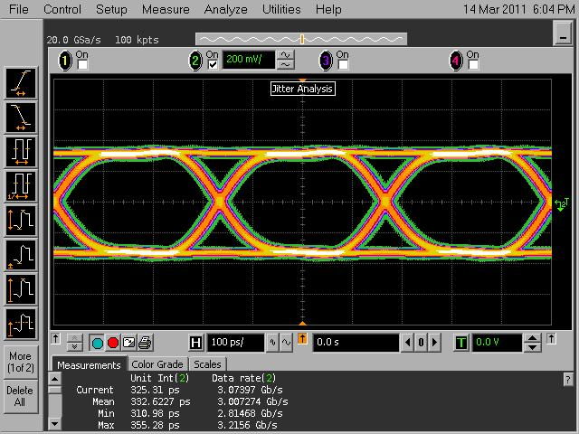
Figure3. UI for Gen1 and Gen2

- TSG-01 Differential Output Voltage
Figure4 shows differential output voltage of Gen1 (1.5G) and Gen2 (3.0G). Test point is TP1.
Gen1 (642.82mV) | Gen2 (630.72mV)
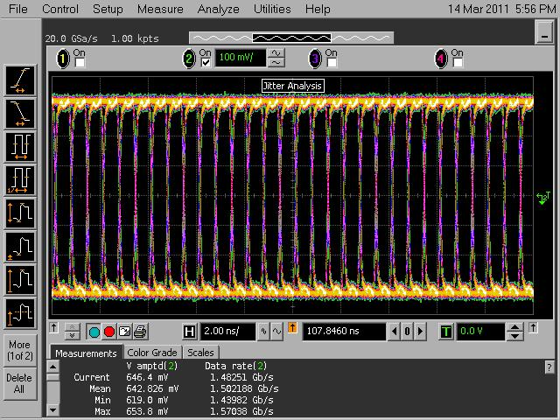 | 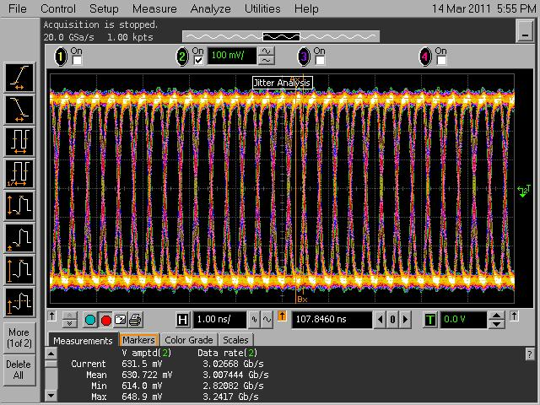
Figure4. Differential Output Voltage for Gen1 and Gen2

- TSG-02 Rise/Fall Time
Figure5 and Figure6 show rise time and fall time of Gen1 (1.5G) and Gen2 (3.0G). Test point is TP1.
Rise Time for Gen1 (89.3ps) | Fall Time for Gen1 (90.6ps)
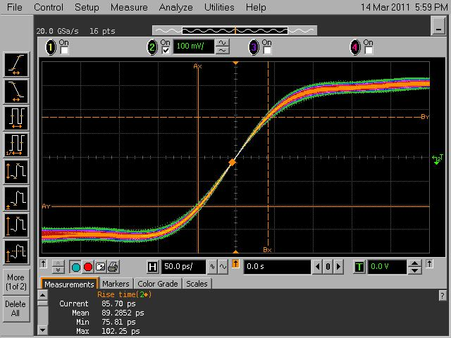 | 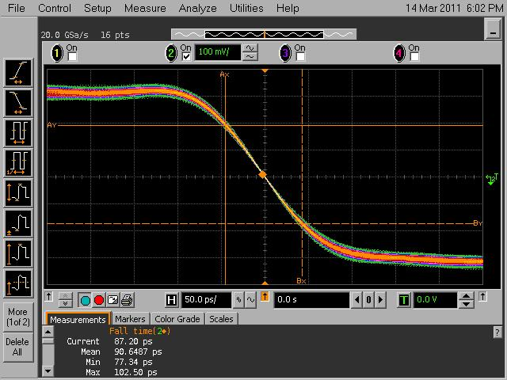
Figure5. Rise Time and Fall Time for Gen1

Rise Time for Gen2 (87.8ps) | Fall Time for Gen2 (89.4ps)
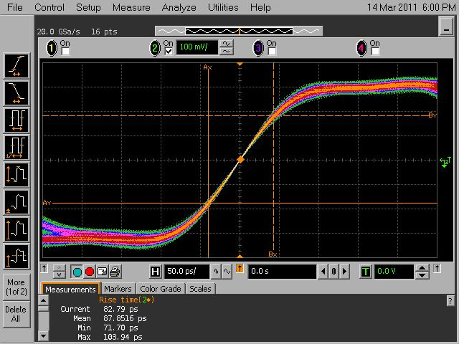 | 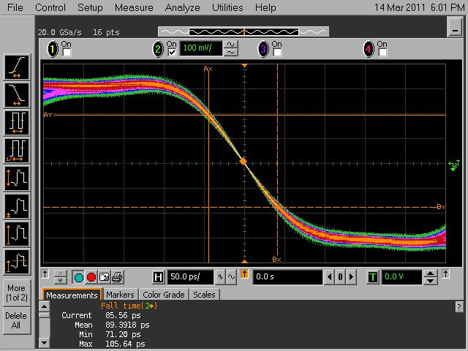
Figure6. Rise Time and Fall Time for Gen2

- TSG-03 Differential Skew
Figure7 shows differential skew of Gen1 (1.5G) and Gen2 (3.0G). Test point is TP1.
Gen1 (9.45ps) | Gen2 (7.64ps)
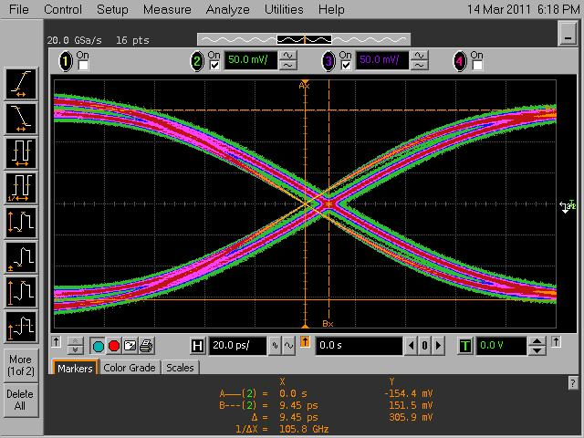 | 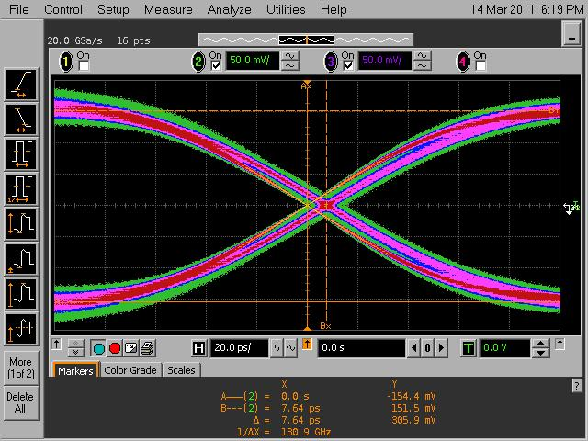
Figure7. Differential Skew for Gen1 and Gen2

- TSG-04 AC Common Mode Voltage
Figure8 shows differential skew of Gen1 (1.5G) and Gen2 (3.0G). Test point is TP1.
Gen1 (32.6/2=16.3mV) | Gen2 (31.6/2=15.8mV)
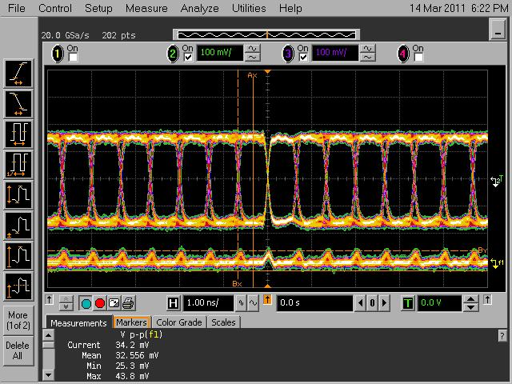 | 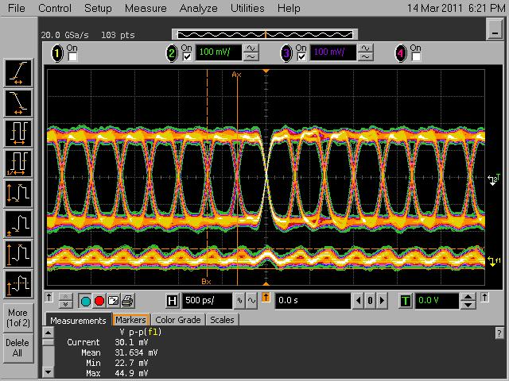
Figure8. AC Common Mode Voltage for Gen1 and Gen2

- OOB Signaling Process
Figure9 shows OOB signaling process. Test point is TP1&TP2.
OOB Signaling Process
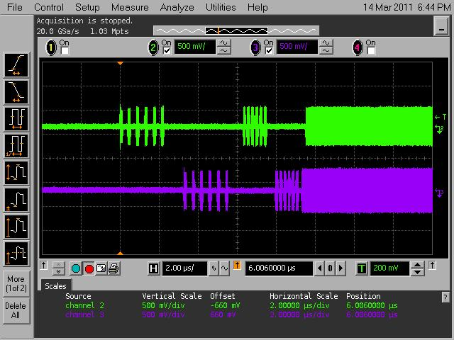
Figure9 OOB Signaling Process
- OOB-01 UI during OOB Signaling
Figure10 shows UI during OOB signaling. Test point is TP1.
UI during OOB Signaling( 654.5ps)
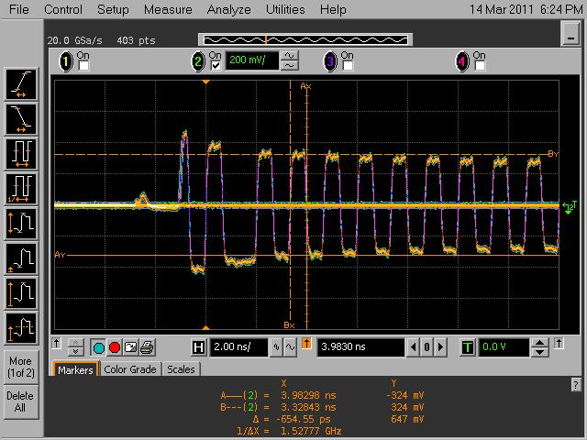
Figure10 UI during OOB Signaling

- OOB-03 COMINIT/RESET Transmit Burst Length
Figure11 shows COMINIT/RESET Transmit Burst Length. Test point is TP1.
Burst Length(107.6ns)
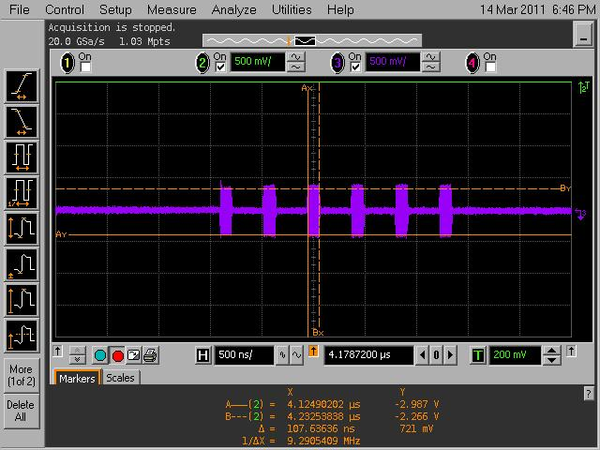
Figure11. COMINIT/RESET Transmit Burst Length

- OOB-04 COMINIT/RESET Transmit Burst Gap Length
Figure12 shows COMINIT/RESET Transmit Burst Gap. Test point is TP1.
Burst Gap Length(318.8ns)
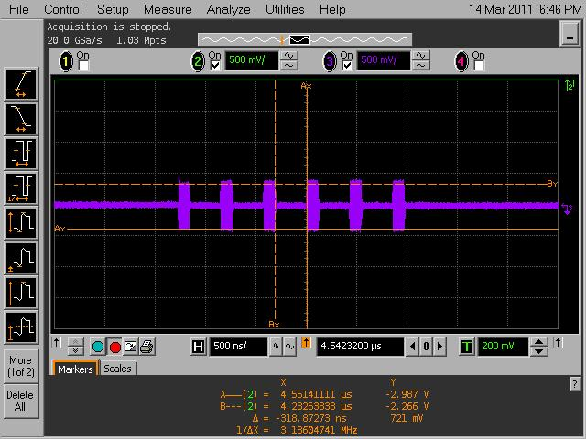
Figure12. COMINIT/RESET Transmit Burst Gap Length

- OOB-05 COMWAKE Transmit Burst Length
Figure13 shows COMWAKE Transmit Burst Length. Test point is TP1.
Burst Length(108.1ns)
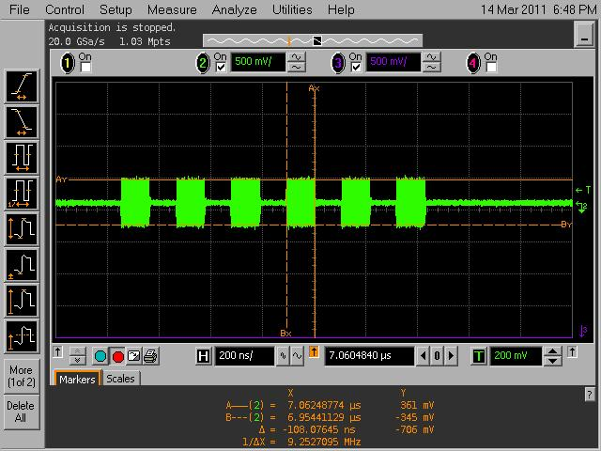
Figure13. COMWAKE Transmit Burst Length

- OOB-03 COMWAKE Transmit Burst Gap Length
Figure14 shows COMWAKE Transmit Burst Gap. Test point is TP1.
Burst Gap Length(105.4ns)
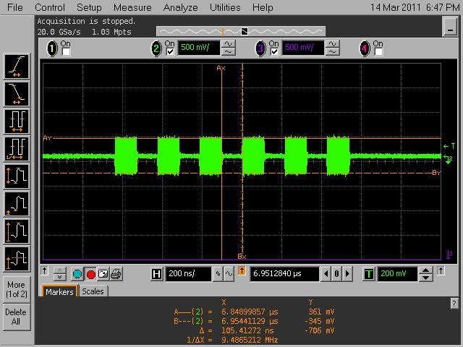
Figure14. COMWAKE Transmit Burst Gap Length

- OOB on/off Time
Figure15. 1st OOB Burst Length.
1st OOB Burst
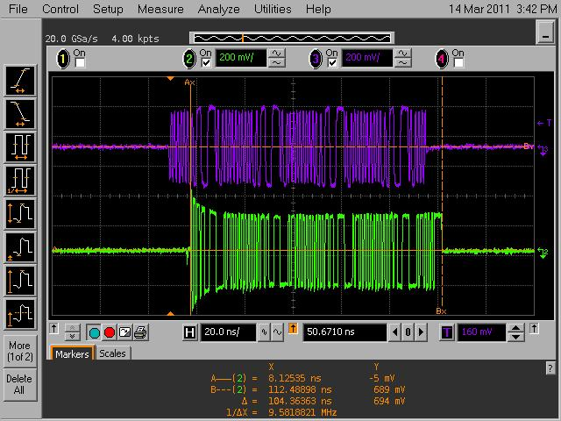
OOB on time(8.86ns) | OOB off time(6.82ns)
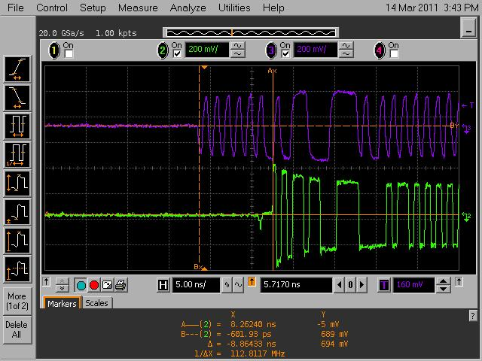 | 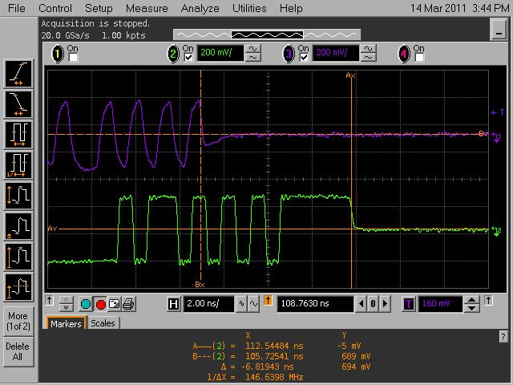
Figure15. OOB on/off time

- Initial OOB Process with LSI SAS Card
Figure16. Initial OOB Process with LSI SAS card
Initial OOB Process | 4th Section of OOB
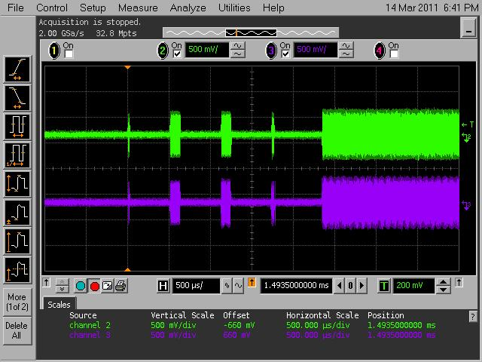 | 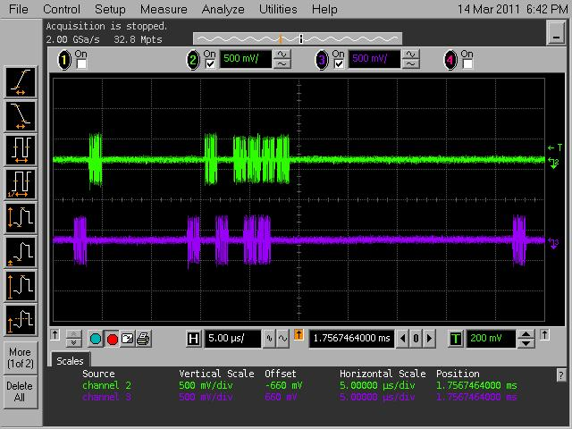
Figure16. Initial OOB Process with LSI SAS card
Power Consumption Test
Below table is power consumption test result for PI3EQX6741ST at 6Gb/s.

Table1. Power consumption Test Result with PI3EQX6741STZDE
Test Condition | Voltage  (Unit: V) | Current  (Unit: mA) | Power Consumption  (Unit: mW)
Active  (no Pre-em of CH A&B) | 3.30 | 77.20 | 254.76
Active  (w/ Pre-emphasis of CH A) | 3.30 | 86.30 | 284.79
Active  (w/ Pre-emphasis of CH B) | 3.30 | 86.40 | 285.12
Active  (w/ Pre-emphasis of CH A&B) | 3.30 | 95.60 | 315.48
HDD Unplugged  (w/o HDD,Tdet_EN=High) | 3.30 | 1.03 | 3.40
Slumber mode  (w/o HDD or Host,Tdet_EN=low) | 3.30 | 11.30 | 37.29
Standby Mode  (EN=Low) | 3.30 | 0.02 | 0.07
Different eSATA HDD Connection Test
Figure17 shows the connection setup and Table2 is different eSATA HDD connection test result.
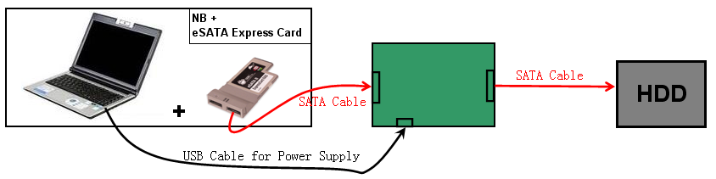
EQX6701CZDE
Figure17. Different eHDD connection Test Setup

Table2. Different eSATA HDD connection Test Result with PI3EQX6741STZDE
Lab S/N | Model Name or  P/N | Manufacturer | w/ Bridge IC |  |  | Test Results
Lab S/N | Model Name or  P/N | Manufacturer | IC Name | Vendor | D.C. | Test Results
BD-001 | T12s/su | JJERA TECHNOLOGY | SPIF225A-HL231 | SunPlusIT | 0805 | pass
BD-002 | YX-32 | PHIYO | JM20316 | JMicron | 0635 | pass
BD-003 | BXE-20A | Zynet | INIC-1610L | Initio | 0711 | pass
BD-004 | T12su | JJERA TECHNOLOGY | INIC-1610PL | Initio | 1004 | pass
BD-005 | HD3-S2 | Mediasonic | SPIF225A-HL231 | SunPlusIT | 0626 | pass
BD-006 | SSK | SzBroad Technology | JM20336 | JMicron | 1010 | pass
BD-007 | 9NL6AG-500 | Seagate | OXU931DS | Oxford Semi | 0648 | pass
Different Internal SATA HDD Connection Test
Figure18 shows the connection using MB and Table3 is different internal SATA HDD result.
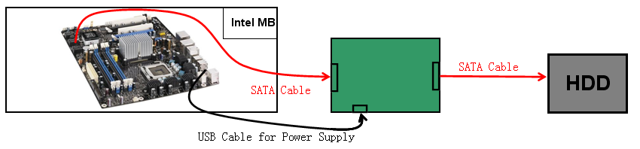
PI3EQX6741ST EVB
MB

Figure18. Different Internal SATA HDD connection Test Setup with MB and PI3EQX6741STZDE

Table3. Different internal SATA HDD using MB with PI3EQX6741STZDE
Lab S/N | Motherboard/Card | Vendor | Chipset or IC Vendor | Test Result
MB-001 | GA-EG45M-UD2H | GigaByte | Intel | pass
MB-002 | A780Full | ASRock | AMD | pass
AD-001 | SATA 6Gb/s Adapter | SIIG | Marvell | pass
AD-002 | SAS 8704ELP | LSI | LSI | pass

History
Version 1.0 Original Version Mar 15, 2011

