PI3USB30532 12port S-Parameter Model Verification

- Introduction:
In order to verify our S parameter model, we need to do some simulations with the measured or simulated model. First is the Frequency characteristic simulation which we can get the insertion loss, return loss, the second is the TDR simulation and lastly we can get the eye-diagram of the transient simulation with the correlated data rate.

- Verification:
- Frequency Characteristic:

12Port S Parameter
port1
port2
port3
port4
port5
port6
Differential port2
Differential port1
Differential Insertion loss = SDD21, SDD34, SDD56
Differential return loss = SDD11, SDD33, SDD55
port7
port8
port9
port10
port11
port12
Differential port4
Differential port6
Differential port3
Differential port5
Simulation waveform:
Differential INSERTION LOSS
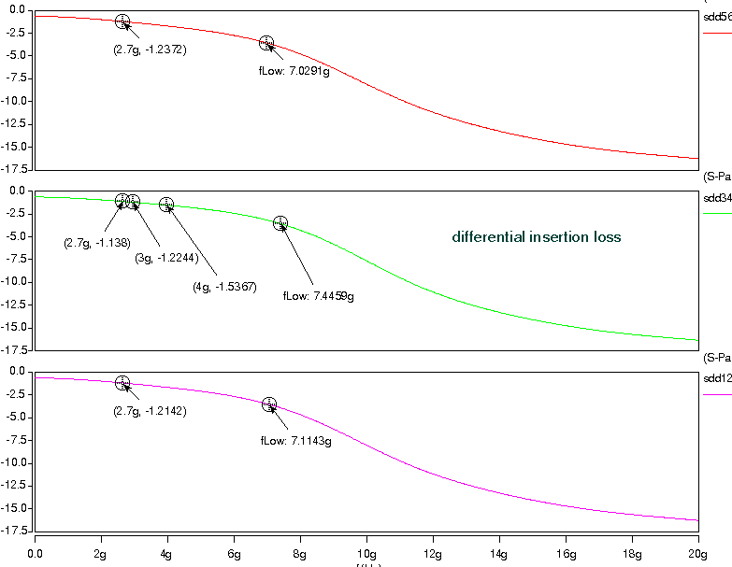
Differential RETURN LOSS
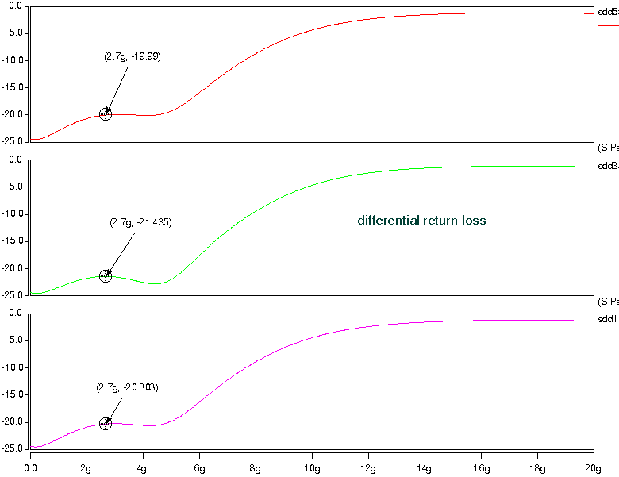
Differential crosstalk
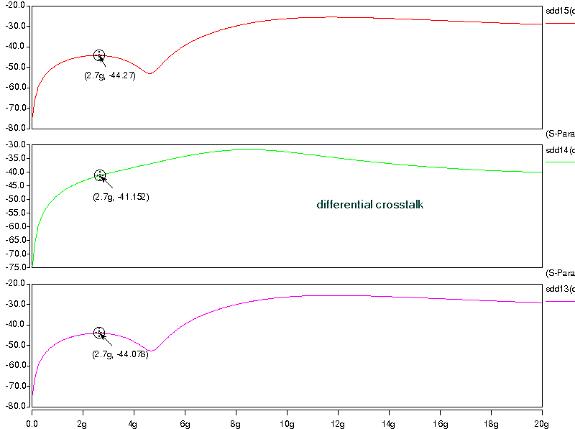

- TDR simulation:
Z=50ohm, Tdelay=1n

12-Port S Parameter
50ohm
50ohm
0.2pF
0.2pF
0
1
Trise=50ps
50ohm
50ohm
50ohm
50ohm
Simulation waveform:
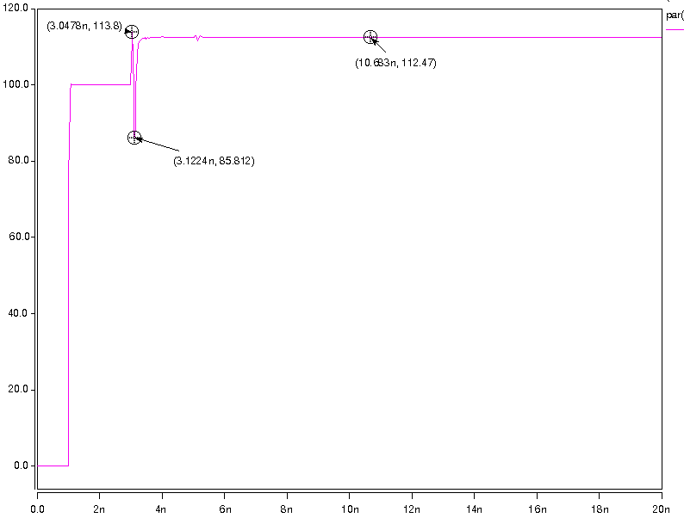

- Transient simulation:
50ohm
50ohm

12-Port S Parameter
50ohm
50ohm
50ohm
50ohm
PRBS7
trace_in
3inch trace
switch_in
output
50ohm
50ohm
Simulation waveform:
Data Rate = 5.4Gbps
