PI3USB31532 DP S-Parameter Model Verification

- Introduction:
In order to verify our S parameter model, we need to do some simulations with the measured or simulated model. First is the Frequency characteristic simulation which we can get the insertion loss and return loss, the second is the TDR simulation and lastly we can get the eye-diagram of the transient simulation with the correlated data rate.

- Verification:
- Frequency Characteristic:

4-Port S Parameter
port1
port2
port3
port4
Differential port2
Differential port1
Differential Insertion loss = SDD21
Differential return loss = SDD11
Simulation waveform:
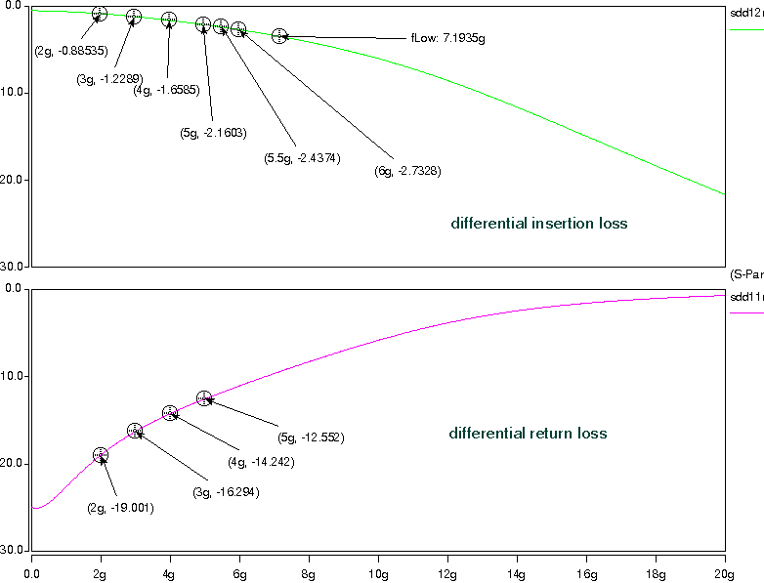

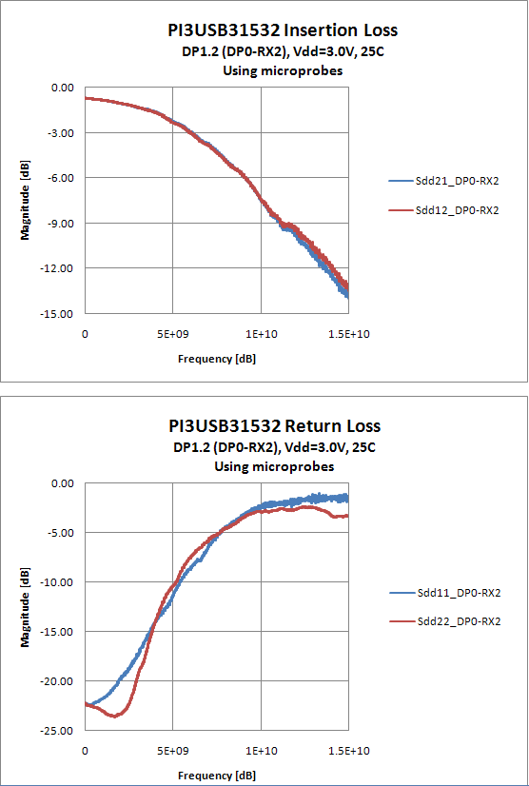

- TDR simulation:
Z=50ohm, Tdelay=1n

4-Port S Parameter
50ohm
50ohm
0.2pF
0.2pF
0
1
Trise=66ps
Simulation waveform:
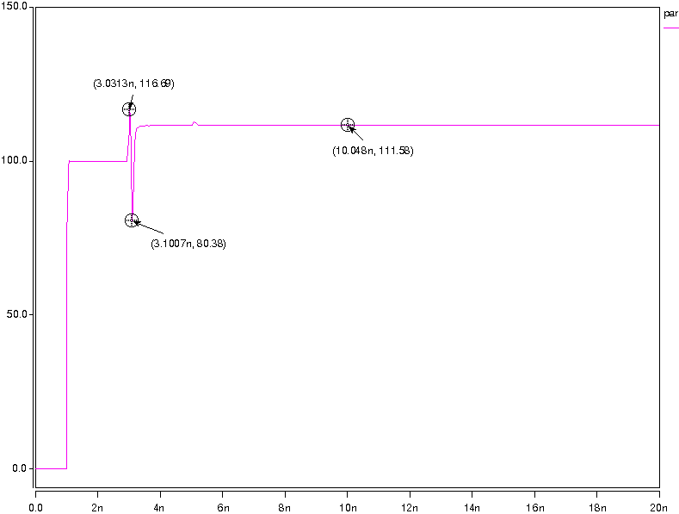

- Transient simulation:

4-Port S Parameter
50ohm
50ohm
50ohm
50ohm
PRBS7
trace_in
1inch trace
switch_in
output
Simulation waveform:
Data Rate = 8Gbps
